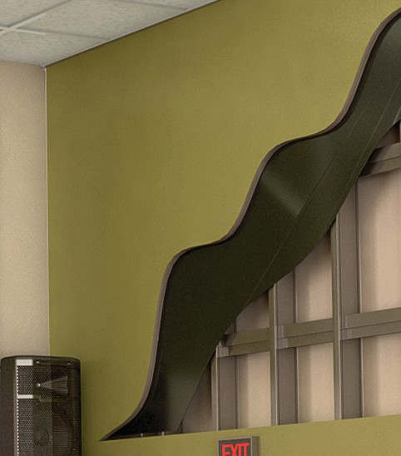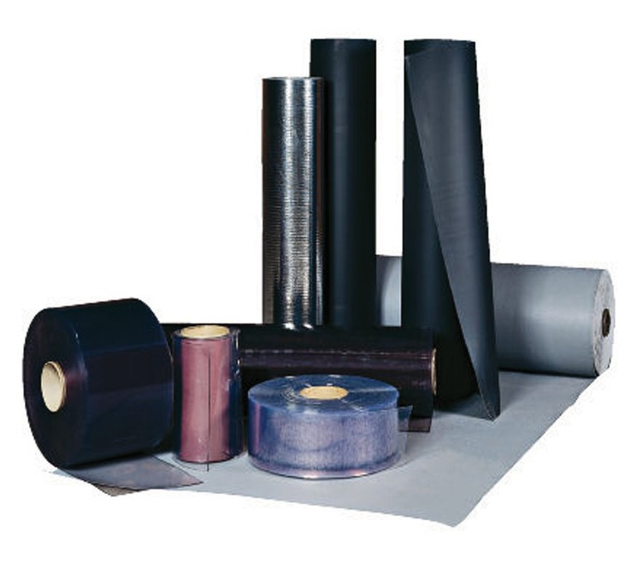

**SPEC DATA SHEET # NCB-104**

4700 Clairton Blvd., Pittsburgh, PA 15236

Tel: (412) 884-3000

[www.oeler.com](http://www.oeler.com/)

•

•

Fax: (412) 884-3300

[sales@oeler.com](mailto:sales@oeler.com)

*Intelligent Acoustic Solutions*

**NCP-104**

**FLEXIBLE NOISE BARRIERS**

Oelex Flexible noise control barriers by Oeler Industries, Inc. are loaded vinyl barriers that combine mass, flexibility, and limpness to block noise from transmitting from one area to

another.

They

are

available

clear,

non-reinforced, and reinforced in a variety of

weights and styles to meet a multitude of applications.

•

Reinforced barrier is available in tan,

blue or gray

Reinforced barriers have excellent UV and weather resistance

Industrial, commercial, construction, residential and OEM applications Used to improve the transmission loss

in standard walls

•

•

•

**FEATURES:**

•

•

Loaded vinyl noise barriers

Reinforced, non-reinforced, transparent and foil-faced lag styles

Mass loaded barriers from 1/2 lb. to 2 lbs. per sq. ft. Acoustical ratings: STC-20 thru STC-31

Limp, flexible, formable, versatile High tear and tensile strength For industrial, construction, commercial, residential and

OEM applications

•

•

•

•

•

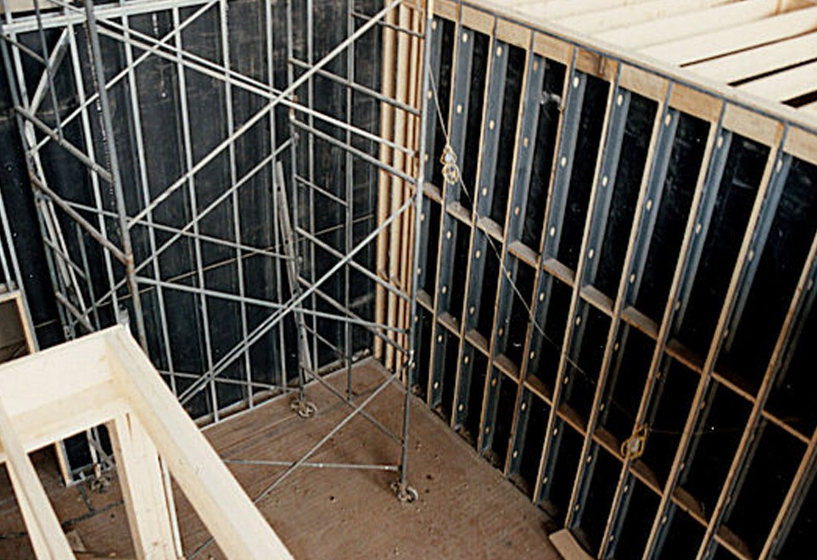

**Physical Properties**



*Intelligent Acoustic Solutions*

**SPEC DATA SHEET # NCP-104**

**Flexible Barriers**

Noise Transmission Loss

Per ASTM: E 90 (90A)

Additional information on tensile, breaking and tear strengths, elongation, chemical resistance, flammability,

etc. available upon request.

The test results reported were obtained using standard laboratory procedures recognized by the technical

community. The data is valid as a measurement of the material under specific controlled test conditions. However, this data does not represent an accurate indicator of the performance of the material or of the hazards which they may exist under actual field conditions.

4700 Clairton Blvd., Pittsburgh, PA 15236

Tel: (412) 884-3000 • Fax: (412) 884.3300

[www.oeler.com](http://www.oeler.com/)

•

[sales@oeler.com](mailto:sales@oeler.com)

*Intelligent Acoustic Solutions*

**Product Nom. Nom. Weight Description Roll Additonal Thickness (in.) lb/sq. ft. Size Details**

B-10 NR .107 1.0

B-5 NR .042 .5

Non-Reinforced 54” W x See Bulletin

B-20 NR .225 2.0 60’L SS101

B-10 LAG .090 1.0 Reinforced

B-5 R .050 .5

B-10 LAG .090 1.0 Foil Faced 54”Wx30’L See Bulletin SS105

B-10 CV .160 1.0 16”Wx100’L & 48”Wx60’L Mounting

B-7.5 CV .102 .75

Transparent Hardware Details

B-5 CV .080 .5 8”Wx300’L & 48”Wx60’L See Bulletin SS102

B-10L .020 1.0 Lead Sheet 48”Wx25’L SS104

B-10MB .100 1.0 Marine Barrier 38”Wx45’L

12”Wx200’L & 48”Wx60’L

**Barriers Noise Transmission Loss (dB) STC Per Octave Band (HZ)**

**125 250 500 1000 2000 4000**

2 lb. PSF 16 22 26 32 35 40 31

1 lb. PSF 13 17 22 26 32 37 26

3/4 lb. PSF 11 16 20 25 30 34 23

1/2 lb. PSF 8 13 17 22 27 31 20