Intelligent Acoustic Solutions

SPEC DATA SHEET # GWC_EX-N
4700 Clairton Blvd., Pittsburgh, PA 15236
Tel: (412) 884-3000 • Fax: (412) 884-3300
www.oeler.com • sales@oeler.com

GWC_EX-N

Sound Curtains
Oelex GWC-EX-N by Oeler Industries, Inc. is an economical noise barrier for outdoor applications. This barrier-wall product consist of a one-pound per sq. ft. non-reinforced loaded vinyl noise barrier. Modular curtain panels are constructed with grommets across the top and bottom, and exterior grade Velcro seals along the vertical edges. Modular panels are sewn with an exterior grade thread.

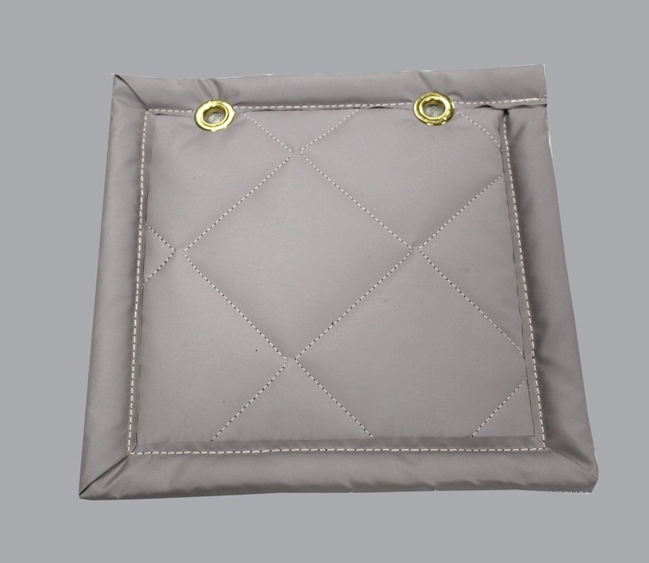
FEATURES:
- STC 26 Rating
- Economical short-term solution
- Available barrier colors: black

4700 Clairton Blvd., Pittsburgh, PA 15236
Tel: (412) 884-3000 • Fax: (412) 884.3300
www.oeler.com • sales@oeler.com
Intelligent Acoustic Solutions

Intelligent Acoustic Solutions
SPEC DATA SHEET # GWC_EX-N

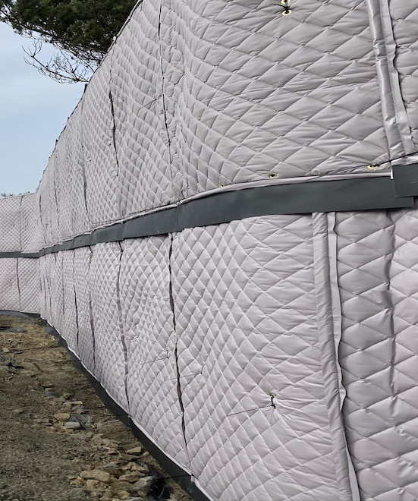
APPLICATIONS:
Typically used as modular curtain panels on short-term construction projects or other applications such as noise control around drilling equipment, enclosing HVAC equipment, dust collectors or similar machinery behind a manufacturing plant.
This is an economical solution where cost is an issue during your project. Also available with a two-inch thick quilted fiberglass absorber, or with a two-pound per sq. ft. reinforced barrier.

PRODUCT DATA
Description: 1 lb-psf non-reinforced loaded vinyl noise barrier
Nominal Thickness: 0.107 inch
Standard Panel Width: 54” wide, lengths as required up to 16’ high
Weight: 1.0 lb psf

ACOUSTICAL PERFORMANCE:
Sound Transmission Loss:
OCTAVE BAND FREQUENCIES (HZ)
Product | 125 | 250 | 500 | 1K | 2K | 4K | NRC
GWC-EX-N | 13 | 17 | 22 | 26 | 32 | 37 | 26
ASTM E-90 & E 413

