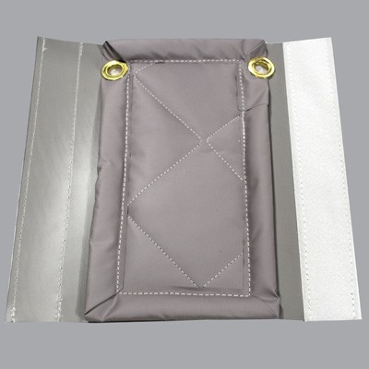

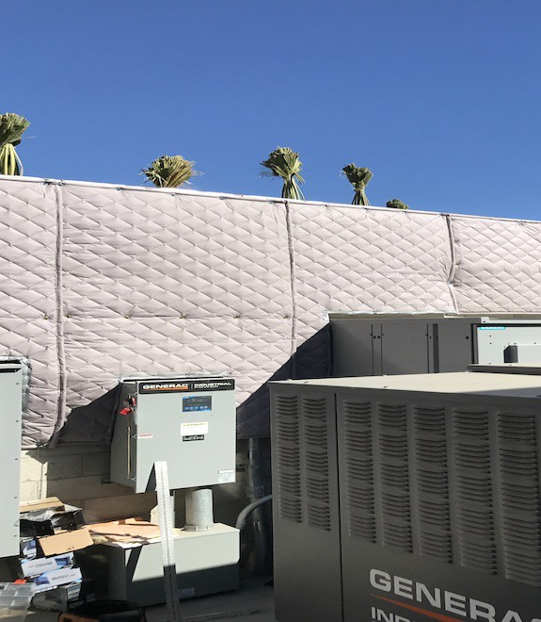

**SPEC DATA SHEET # GWC_EX-R**

4700 Clairton Blvd., Pittsburgh, PA 15236

Tel: (412) 884-3000

[www.oeler.com](http://www.oeler.com/)

•

•

Fax: (412) 884-3300

[sales@oeler.com](mailto:sales@oeler.com)

*Intelligent Acoustic Solutions*

**GWC-EX-R**

**SOUND CURTAINS**

The Oelex by Oeler Industries, Inc. GWC_EX-R is a

noise

barrier

for

outdoor

applications.

This

barrier-wall product consists of an exterior grade, UV

resistant heavy-duty, one-pound per sq. ft. reinforced loaded vinyl noise barrier. Its high strength polyester fabric reinforcement is utilized in the center of the barrier to dramatically improve its durability, tear and hanging strength.

Modular

certain panels

are

constructed

with

grommets across the top and bottom, and exterior

grade Velcro seals along the vertical edges. Modular panels are sewn with an exterior grade thread.

**FEATURES:**

•

•

•

STC 26 Rating

Excellent outdoor UV and weather resistance Available barrier colors: gray, tan, olive drab or green

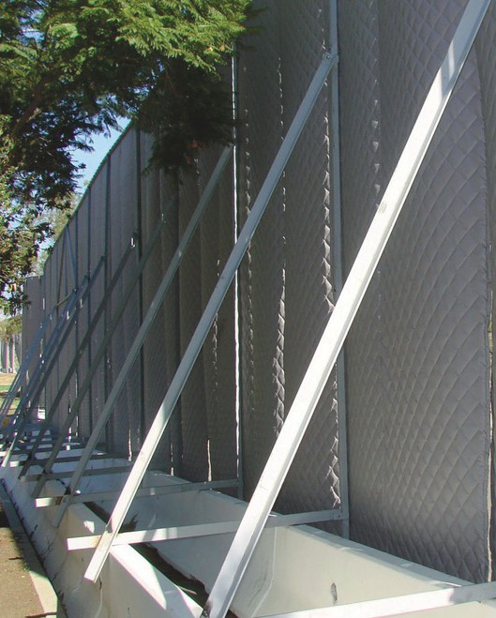



*Intelligent Acoustic Solutions*

**SPEC DATA SHEET # GWC_EX-R**

**APPLICATIONS:**

Typically used as a modular certain panels on long-term construction projects or permanent outdoor applications such as noise control around drilling equipment, enclosing HVAC equipment, dust collectors or similar machinery behind a manufacturing plant, where UV and abuse resistance as well as maximum durability, longevity and noise reduction is required. Also available with a two-inch thick quilted fiberglass absorber, or with a two-pound per sq. ft. reinforced barrier.

**PRODUCT DATA:**

**Description:**1 lb-psf reinforced loaded vinyl noise barrier

**Nominal Thickness:** 0.090 inch

**Temperature Range:** -20Y to +180Y F

**Standard Panel Width:** 54” wide, lengths as required up to 16’ high

**Weight:** 1.0 lb psf

**ACOUSTICAL PERFORMANCE:**

**Sound Transmission Loss:**

**OCTAVE BAND FREQUENCIES (HZ)**

ASTM E-90 & E 413

4700 Clairton Blvd., Pittsburgh, PA 15236

Tel: (412) 884-3000 • Fax: (412) 884.3300

[www.oeler.com](http://www.oeler.com/)

•

[sales@oeler.com](mailto:sales@oeler.com)

*Intelligent Acoustic Solutions*

**Product 125 250 500 1K 2K 4K NRC**

**GWC_EX-R** 13 17 22 26 32 37 26