Intelligent Acoustic Solutions

OELEX-GDI

GARAGE DOOR ISOLATOR
The OELEX-GDI (Garage Door Isolator) by Oeler Industries, Inc. decouples the vibrations from your garage door opener when it is in operation. The OELEX-GDI kit has a motor isolator and rail isolators. You can purchase the motor isolator by itself or with the rail kits for a complete vibration isolation system.

APPLICATIONS:
- Apartment
- Condo
- Commercial
- Retail
- Conference Room
- Recording Studio
- Home Theater
- Commercial Theater

SPEC DATA SHEET # OELEX-GDI
4700 Clairton Blvd., Pittsburgh, PA 15236
Tel: (412) 884-3000 • Fax: (412) 884-3300
www.oeler.com • sales@oeler.com

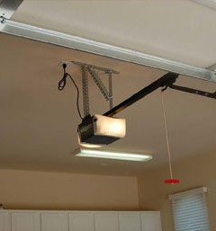
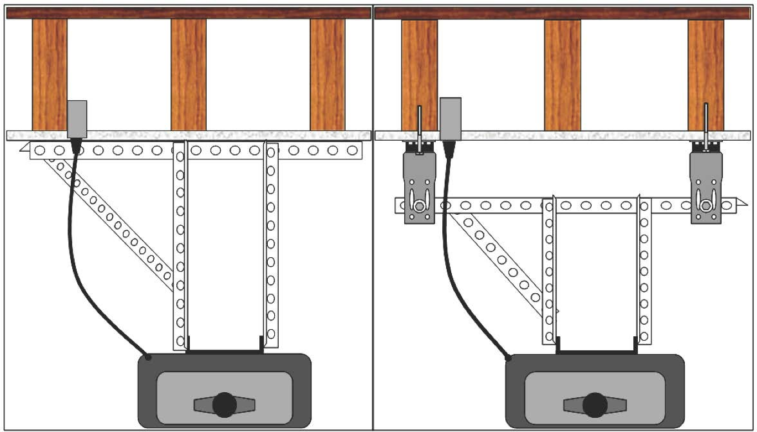
BEFORE AFTER

FEATURES:
- Available for wood, steel, metal deck, concrete

Intelligent Acoustic Solutions
4700 Clairton Blvd., Pittsburgh, PA 15236
Tel: (412) 884-3000 • Fax: (412) 884.3300
www.oeler.com • sales@oeler.com
Intelligent Acoustic Solutions

SPEC DATA SHEET # OELEX-GDI
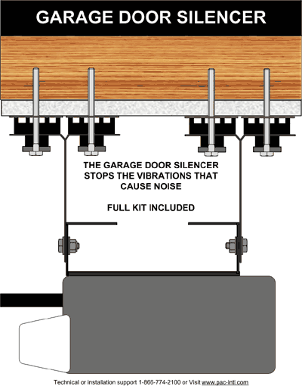

OELEX-GDI SPECIFICATIONS:

Acoustical Design Load: | 144 lbs
Total Deflection: | 3 mm
Double Deflection: | YES
LOW VOC: | YES
Adjustable: | YES
Adjustment Limit: | Bracket Length
Use on Ceilings: | YES
Use on Walls: | NO
New Construction: | YES
Retro Fit: | YES
Tested, Engineered, Designed, and Calibrated In USA

Available in three different kits:

- OELEX-Garage Door Motor Isolator Kit
- OELEX-Garage Door Rail Isolator Kit
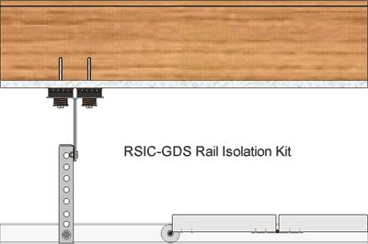
- OELEX-Garage Door Complete Isolation Kit

