Intelligent Acoustic Solutions

OX-B10 NR Noise Barrier

Mass-loaded Vinyl
The Oelex B-10 NR by Oeler Industries, Inc. is a flexible non-reinforced mass-loaded vinyl barrier that is designed to reduce the transmission of noise through walls, ceilings, and floors. Also used as a noise barrier component in acoustical composites.

Applications:
Typically used as a noise barrier in gypsum wallboard and stud construction to substantially improve transmission loss between rooms. Also, utilized as a barrier septum material in acoustical curtain construction to form BSC style composites.
SPEC DATA SHEET # OX-B10 Series
4700 Clairton Blvd., Pittsburgh, PA 15236
Tel: (412) 884-3000 • Fax: (412) 884-3300
www.oeler.com • sales@oeler.com

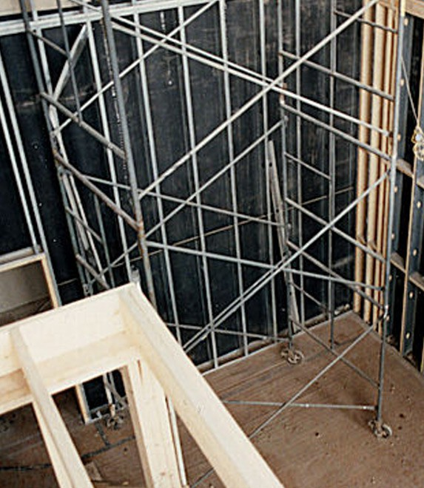

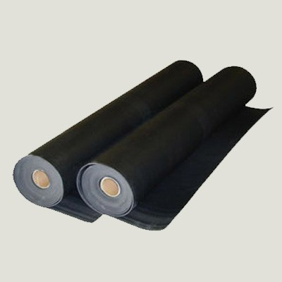
FEATURES:
- Rolls are available 54" wide up to 60' long
- Limp, flexible, formable, versatile
- High tear and tensile strength
- Extremely easy to install

Intelligent Acoustic Solutions
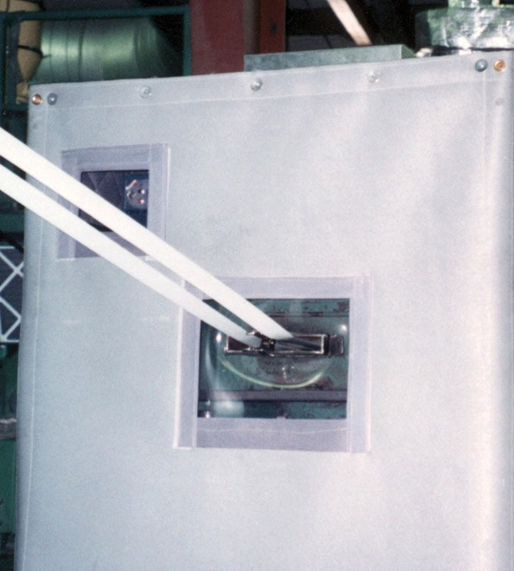
SPEC DATA SHEET # OX-B10 NR

PRODUCT DATA:
Description

Nominal thickness Standard width Roll length
Weight Tensile (PSI) Elongation
Service Temperature

1 lb-psf non-reinforced loaded vinyl barrier
0.10 inches
54" wide
30' or 60' long
1.0 lb psf
220
140%
-20° F to +180°

4700 Clairton Blvd., Pittsburgh, PA 15236
Tel: (412) 884-3000 • Fax: (412) 884.3300
www.oeler.com • sales@oeler.com
Intelligent Acoustic Solutions

ACOUSTICAL DATA:

Sound Transmission Loss (dB) Frequency (Hz)

Product | 125 | 250 | 500 | 1000 | 2000 | 4000 | STC
OX-B10 NR | 13 | 17 | 22 | 26 | 32 | 37 | 26
ASTM E-90 & E 413

