Intelligent Acoustic Solutions

OX-B20 NR Noise Barrier

Mass-loaded Vinyl
Oelex B-20 NR by Oeler Industries, Inc. is a flexible non-reinforced mass-loaded vinyl noise barrier that is designed to reduce the transmission of noise through walls, ceilings, and floors. B-20 NR is a two-pound per sq. ft. material specifically designed to offer greater noise attenuation than standard one-pound per sq. ft. products, primarily at low frequencies.

Applications:
Typical uses include as a noise barrier in drywall and stud construction to substantially improve transmission loss between rooms. Also, utilized as a barrier septum material in acoustical curtains and foam composites.
SPEC DATA SHEET # OX-B20 Series
4700 Clairton Blvd., Pittsburgh, PA 15236
Tel: (412) 884-3000 • Fax: (412) 884-3300
www.oeler.com • sales@oeler.com

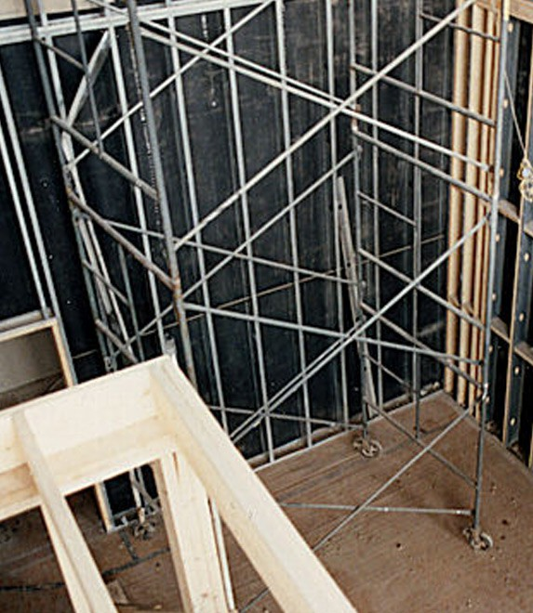

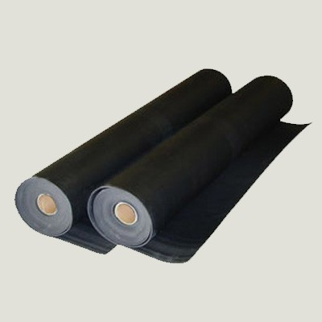
FEATURES:
- Rolls are available 54” wide x 30’ long
- Easy to install
- Limp, flexible, formable, versatile
- High tear and tensile strength

Intelligent Acoustic Solutions
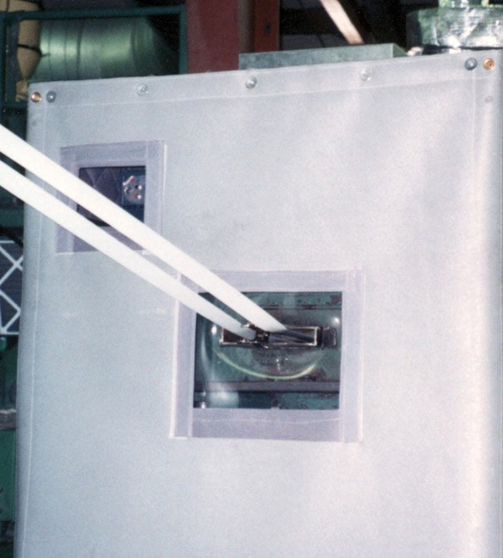
SPEC DATA SHEET # OX-B10 NR

PRODUCT DATA:
Description

Nominal thickness Standard width Roll length
Weight

2 lb-psf non-reinforced loaded vinyl barrier
0.23 inches
54" wide
60' long
2.0 lb psf

4700 Clairton Blvd., Pittsburgh, PA 15236
Tel: (412) 884-3000 • Fax: (412) 884.3300
www.oeler.com • sales@oeler.com
Intelligent Acoustic Solutions

ACOUSTICAL DATA:

Sound Transmission Loss (dB) Frequency (Hz)

Product | 125 | 250 | 500 | 1000 | 2000 | 4000 | STC
OX-B20 NR | 16 | 22 | 26 | 32 | 35 | 40 | 31
ASTM E-90 & E 413

