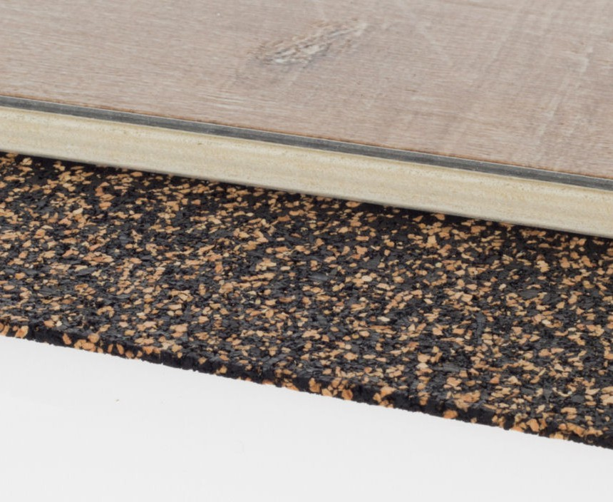

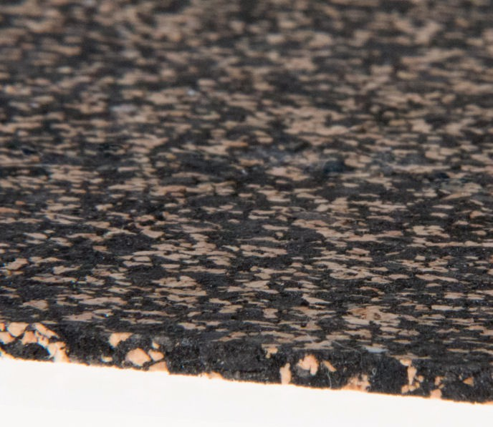

**SPEC DATA SHEET # OX-SOFTSTEP**

4700 Clairton Blvd., Pittsburgh, PA 15236

Tel: (412) 884-3000

[www.oeler.com](http://www.oeler.com/)

•

•

Fax: (412) 884-3300

[sales@oeler.com](mailto:sales@oeler.com)

*Intelligent Acoustic Solutions*

**OX-SOFTSTEP**

**SOFTSTEP**

Oeler Industries, Inc. Oelex Softstep contains zero

rubber so plasticize migration will not occur and is made entirely of polyurethane foam and cork. Oelex Softstep is age resistant for decades for durability under point loads and at only 3mm but will add excellent acoustic improvement to the floor assembly.

•

Offers long term performance without collapse or

bottoming out

Suitable for both new construction & renovations Quick & easy installation

Resistant to aging & deformation

•

•

•

**FEATURES:**

•

Sound reducing underlayment for floated wood

laminate and engineered wood floor systems Excellent for wood construction, will add additional sound transmission (STC) due to weight of product Economically priced, availabe in 4’x25’ & 4’x50’ rolls

Environmentally friendly, made from recycled materials, using 92% post-consumber recycled content

Can be installed as a free-floating or glue-down system

•

•

•

•

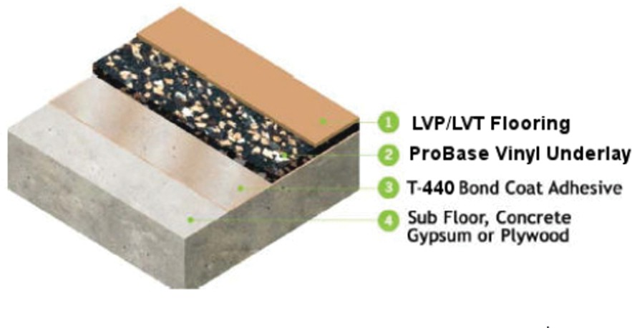



*Intelligent Acoustic Solutions*

**SPEC DATA SHEET # OX-SOFTSTEP**

**APPLICATIONS:**

Specifically designed for use under both dry back and glue down LVP/LVT, sheet vinyl, carpet and carpet tile flooring.

**SPECIFICATIONS:**

**Material:** Polyurethane foam/ cork **Roll Size:** 39” x 65’ x 6“ (213 sq ft roll) **Thickness:** 3mm

**Weight Per Roll:** 65 lbs.

**Density:** 45 lbs./ cubic ft

**Hardness A Shore Durometer:** 54-64 **Temperature Resistance:** -40 - 110c **Sound Reduction:** llC 22

**ACOUSTIC PERFORMANCE:**

**Thickness**

**Wood Frame**

**6” Concrete**

Note: Results may vary depending upon building and floor configurations. Test procedure methods per standards set forth by ASTM E492-90, ASTM E-989-89, ASTM E-1007097, and ASTM E2179-03.

4700 Clairton Blvd., Pittsburgh, PA 15236

Tel: (412) 884-3000 • Fax: (412) 884.3300

[www.oeler.com](http://www.oeler.com/)

•

[sales@oeler.com](mailto:sales@oeler.com)

*Intelligent Acoustic Solutions*

3mm llC 57 21

6mm llC 57 22

12mm llC57 23