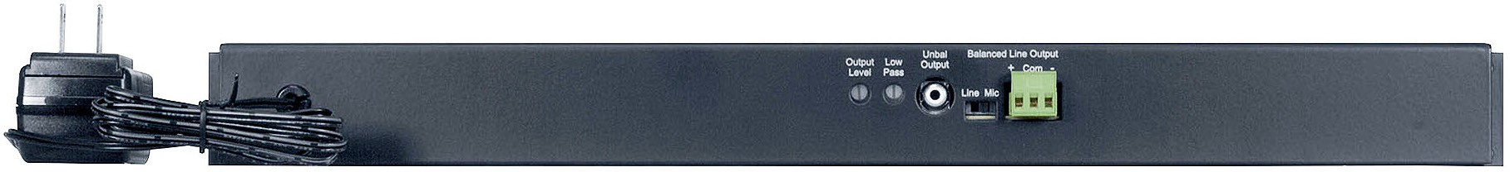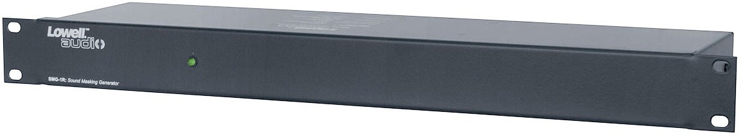



**SPEC DATA SHEET # OX DSP-1**

4700 Clairton Blvd., Pittsburgh, PA 15236

Tel: (412) 884-3000

[www.oeler.com](http://www.oeler.com/)

•

•

Fax: (412) 884-3300

[sales@oeler.com](mailto:sales@oeler.com)

*Intelligent Acoustic Solutions*

**OX DSP-1**

**SOUND MASKING GENERATOR**

Model #SMG-1R rack mount generator produces and analog pink noise signal for systems that utilize a separate amplifier to drive the sound masking speakers (ordered separately), in order to produce random low-level background noise to mask ambient noise and aid conversational privacy.

**FEATURES:**

* Generator outputs include high impedance line (RCA jack) and balance line that can be switched between line level and mic level (terminal strip) for matching input requirements of most commercial equalizers and amplifiers.
* Controls include output level and an adjustable low pass filter that shapes frequencies at 9dB per octave with roll off at 300Hz.
* Also handy for system equalization and audio equipment testing.

**SPECIFICATIONS:**

**FRONT VIEW**

-

-

-

-

-

Noise Type:

Unbalanced Output: Low Pass Filter: Chassis:

Power Supply:

Analog pink (equal energy per octave)

500mV

500mV (line); 5mV (mic)

Full Right (flat); Full Left (30GHz roll off) Steel with black powder epoxy finish (19" x 4" x 1.75")

**REAR VIEW**

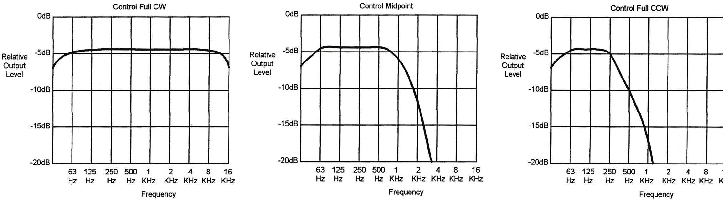



*Intelligent Acoustic Solutions*

**SPEC DATA SHEET # OX DSP-1**

**A&E SPECIFICATIONS**

The rackmount sound making generator (without amplifier)

shall be Lowell model SMG-1R, which shall produce an analog pink nose signal. It shall have a balanced low-impedance line output that may be switched between the line level (500mV) and mic level (5mV), and a

high-impendence

unbalanced

line

output

(500mV).

Controls shall include output level and low pass filter. The

steel rackmount chassis shall have a black powder epoxy

finish and measure 19” x 4” x 1U. An external

supply with four plug adaptors shall be included.

power

**TYPICAL CONFIGURATION**

Aux. Input

(Optional)

Noise Output

**LOW PASS FILTER RESPONSE (APPROXIMATE)**

4700 Clairton Blvd., Pittsburgh, PA 15236

Tel: (412) 884-3000 • Fax: (412) 884.3300

[www.oeler.com](http://www.oeler.com/)

•

[sales@oeler.com](mailto:sales@oeler.com)

*Intelligent Acoustic Solutions*

Equalizer

Masking Speakers

Amplifier

Generator