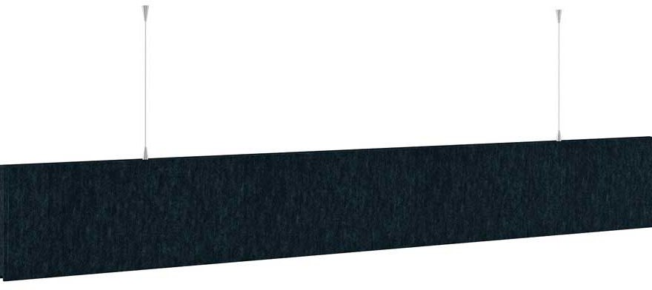

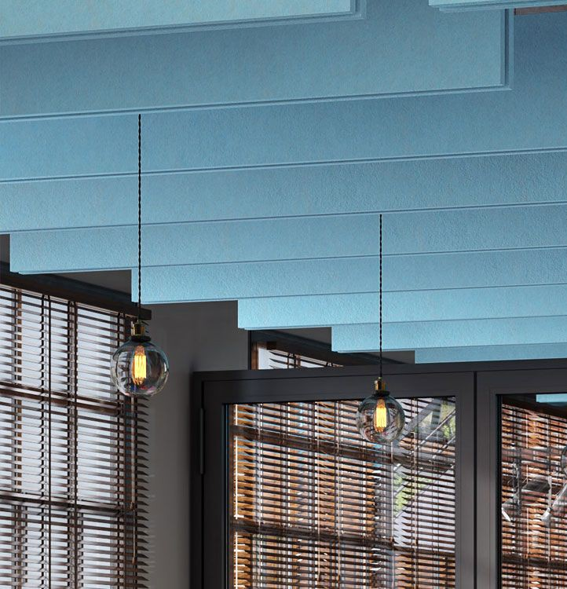

**SPEC DATA SHEET # POLY BAFFLE**

4700 Clairton Blvd., Pittsburgh, PA 15236

Tel: (412) 884-3000

[www.oeler.com](http://www.oeler.com/)

•

•

Fax: (412) 884-3300

[sales@oeler.com](mailto:sales@oeler.com)

*Intelligent Acoustic Solutions*

**BAFFLE SERIES**

**POLY BAFFLE**

The Oelex Poly Baffle by Oeler Industries,

Inc. is an economic,

efficient solution

to

sound

reverberation

issues. This baffle

is

comprised of

a

heat sealed

polyethylene bag encompassing a

sound

black colors

absorptive fiberglass.

White

or

facings are standard, with additional

available.

The baffles are 4’x2’ with two grommets

on one 4’ side for suspending the baffles from wire or cable ties.

**FEATURES:**

•

•

•

•

NRC rating 11.0 per 4’ x 2’ baffle

Class A (or 1) per ASTM E84 The white facing is light reflective Lightweight

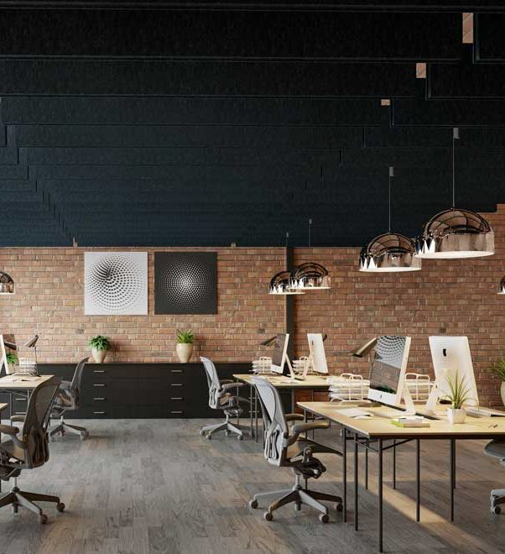



*Intelligent Acoustic Solutions*

**SPEC DATA SHEET # POLY BAFFLE**

**APPLICATIONS:**

Typically used in areas where you want to

introduce soft sound absorption materials into hard, reflective environments to reduce the reverberant noise energy in a room. Such as wood working facilities, manufacturing plants and warehouses, gymnasiums, environmental control booths, and audio booths.

**PRODUCT DATA:**

**Description:** 1.6 lb per cu. ft. fiberglass core

heat-sealed inside a 3-mil polyethylene bag.

**Nominal Thickness:** 1 1/2 inches

**Weight:** 2 lbs per baffle

**Standard Size:** 48” x 24”

**ACOUSTICAL PERFORMANCE:**

**(Sabins per 4’x2’ baffle)**

**OCTAVE BAND FREQUENCIES (HZ)**

Test Method: ASTM C423-99a and C423-81

4700 Clairton Blvd., Pittsburgh, PA 15236

Tel: (412) 884-3000 • Fax: (412) 884.3300

[www.oeler.com](http://www.oeler.com/)

•

[sales@oeler.com](mailto:sales@oeler.com)

*Intelligent Acoustic Solutions*

**Product 125 250 500 1K 2K 4K NRC**

**Polywrap baffle** 2.1 6.5 10.7 14.1 12.7 8.1 11.0