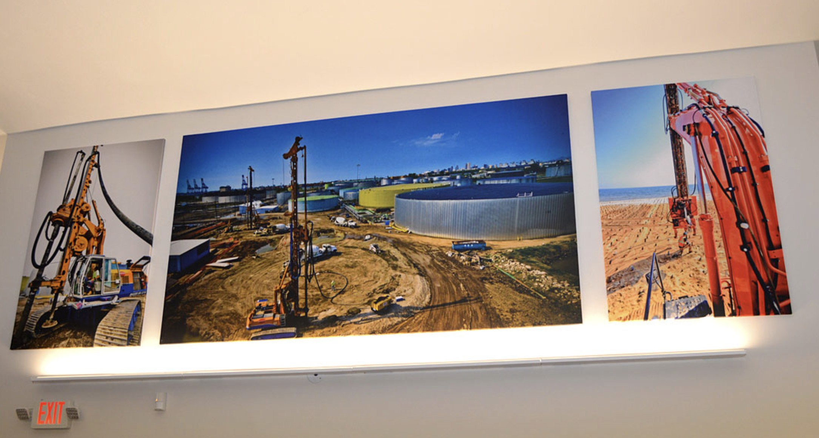

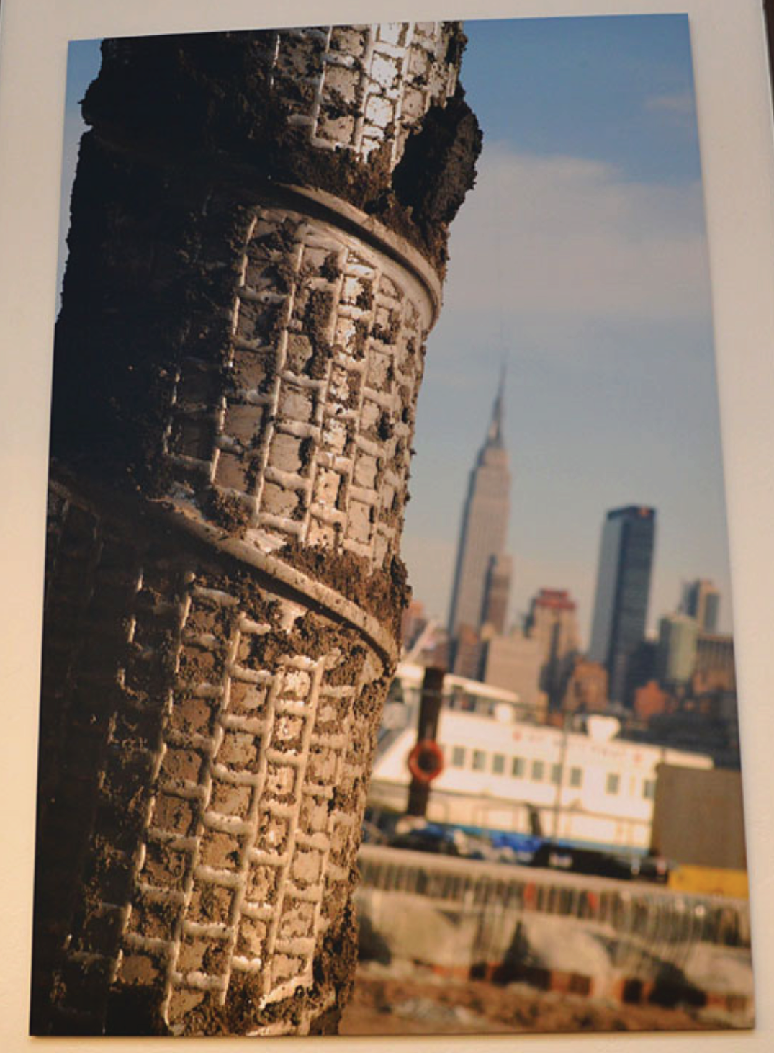

**SPEC DATA SHEET # SONIC PRINTING**

4700 Clairton Blvd., Pittsburgh, PA 15236

Tel: (412) 884-3000

[www.oeler.com](http://www.oeler.com/)

•

•

Fax: (412) 884-3300

[sales@oeler.com](mailto:sales@oeler.com)

*Intelligent Acoustic Solutions*

**SONIC PRINTING**

**PRINTED ACOUSTIC PANELS**

Oelex Custom Printed Acoustical Wall Panels

by

Oeler

Industries,

Inc. offer

a

visually

appealing

problems.

way to resolve reverberant noise

Add your logo or custom art on

these premium acoustic panels guaranteed

to

improve

the

aesthetics

and

acoustics

of your existing space.

**APLICATIONS:**

•

•

•

•

•

•

•

Restaurants

Office spaces Schools Universities Airports Churches

Any area where excess

reverberation is a problem

**FEATURES:**

•

•

•

•

Custom sizes available

Excellent acoustical values

Visually appealing acoustic solution Custom printed

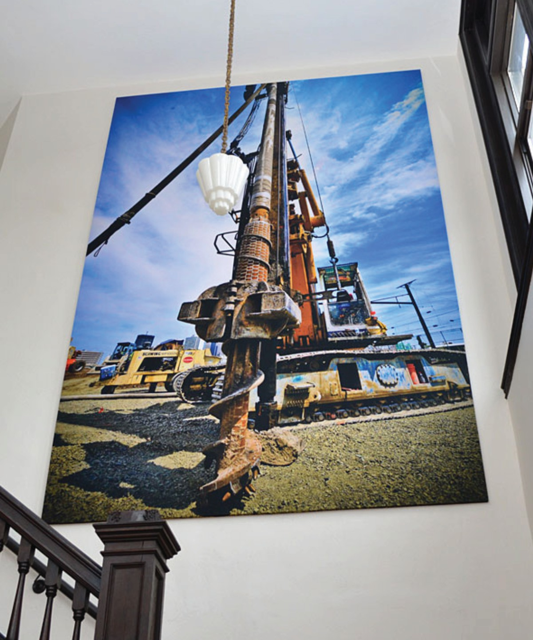



*Intelligent Acoustic Solutions*

**SPEC DATA SHEET # PRINTED ACOUSTIC PANELS**

**SIZING:**

Available in standard and custom sizes up to a maximum of 4’x10‘.

**THICKNESS:**

* Standard thicknesses: 1” and 2”
* Custom thicknesses available

**SUBSTRATES:**

6-7# PCF rigid fiberglass core

**EDGE DETAIL:**

A chemically hardened edge comes standard on all panels unless otherwise requested.

* Square
* Radius
* Bevel
* Miter

**MOUNTING OPTIONS:**

* Rotofast Snap-on Anchors
* Impaling Clips
* 2-Part Mechanical Clips

**ACOUSTICAL PERFORMANCE:**

**1/3 Octave Sound Absorption Coefficients at the Octave Band Frequencies**

4700 Clairton Blvd., Pittsburgh, PA 15236

Tel: (412) 884-3000 • Fax: (412) 884.3300

[www.oeler.com](http://www.oeler.com/)

•

[sales@oeler.com](mailto:sales@oeler.com)

*Intelligent Acoustic Solutions*

**Frequency (Hz) 125 250 500 1K 2K 4K NRC SAA**

**1” Thick** 0.04 0.29 0.74 1.00 1.01 1.00 0.75 0.77