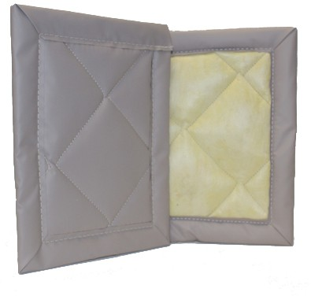

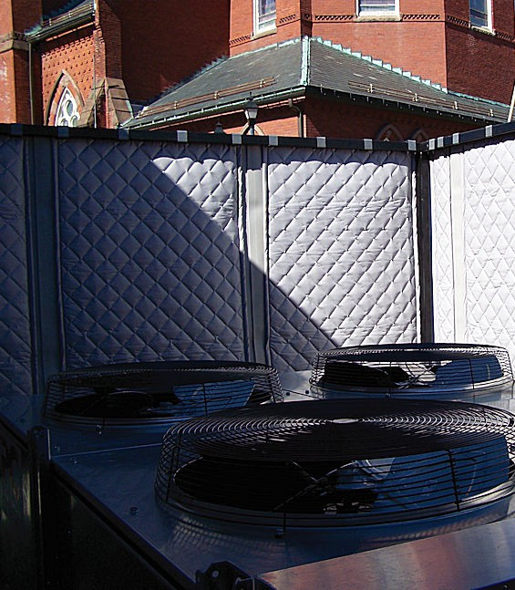

**SPEC DATA SHEET # QFA BAFFLES**

4700 Clairton Blvd., Pittsburgh, PA 15236

Tel: (412) 884-3000

[www.oeler.com](http://www.oeler.com/)

•

•

Fax: (412) 884-3300

[sales@oeler.com](mailto:sales@oeler.com)

*Intelligent Acoustic Solutions*

**BAFFLE SERIES**

**QFA BAFFLES**

Oelex

overhead

Quilted

Fiberglass

line

of

baffles

by

Oeler

durable

Industries,

vinyl-coated

Inc.

feature a

fiberglass-cloth facing quilted

to a one-inch or two-itch thick fiberglass.

These Class

baffles offering available in a

A

Flammability

Rated

high NRC

number of

ratings, are

colors

and

stitch

patterns,

and

can

be

custom

fabricated to any size required.

The Oeler Industries QFA Baffles are

also

available with either a decorative

fabric facing or a nylon ripstop facing.

These attractive sound absorbers offer a wide rand of colorful options which can be custom tailored for any commercial or architectural application.

**FEATURES:**

* Superior UV and weather resistance
* Available facing colors on quilt: gray, tan, black, off-white

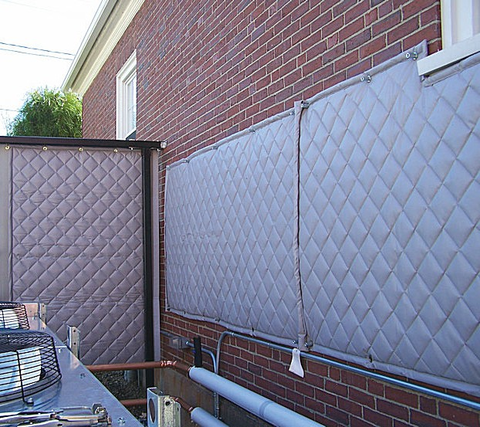



*Intelligent Acoustic Solutions*

**SPEC DATA SHEET # QFA BAFFLES**

**PHYSICAL PROPERTIES:**

* Gray, tan, white, or black are standard vinyl-coated-fiberglass-cloth facings

•

Meets Class A Flammability Rating (ASTM E-84)

Flame Spread: 17.66

Smoke Density: 22.75

Brass grommets installed for hanging Continuous service temp: -200F to 1800F 2 lb./cu. ft. density fiberglass

Decorative fabric and nylon ripstop facings

•

•

•

•

available in over 60 colors

* Quilted diamond patterns or straight-stitch patterns available
* Custom sizes available

**ACOUSTICAL DATA:**

**Quilted Fiberglass Styles**

QFA-4 Baffles: 2’ x 4’ x 1” thick

QFA-10 Baffles: 2’ x 4’ x 2” thick

**Sound Absorption Coefficients-Sabins Per Baffle:**

**ONE-THIRD OCTAVE BAND CENTER FREQUENCIES (HZ)**

Test method: ASTM C423-81

4700 Clairton Blvd., Pittsburgh, PA 15236

Tel: (412) 884-3000 • Fax: (412) 884.3300

[www.oeler.com](http://www.oeler.com/)

•

[sales@oeler.com](mailto:sales@oeler.com)

*Intelligent Acoustic Solutions*

**Sanitary Baffle 125 250 500 1K 2K 4K NRC**

**QFA-4** .59 2.43 7.17 8.66 8.82 6.71 6.75

**QFA-10** .91 6.07 8.25 8.88 6.65 5.58 7.45