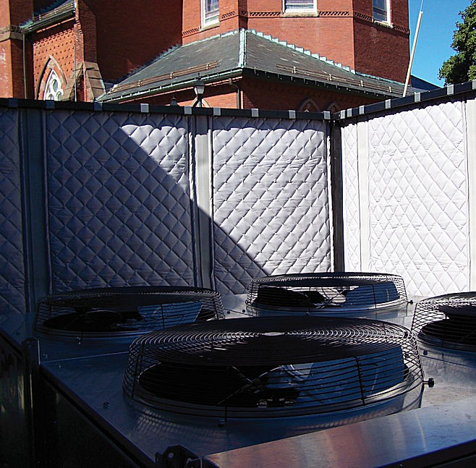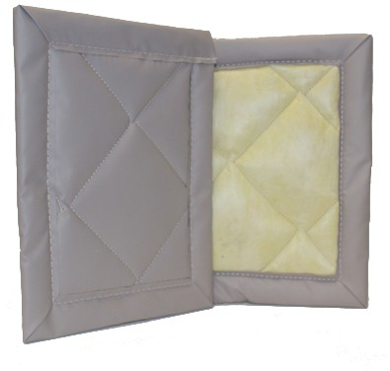

**SPEC DATA SHEET # QFA-EXT-D2**

4700 Clairton Blvd., Pittsburgh, PA 15236

Tel: (412) 884-3000

[www.oeler.com](http://www.oeler.com/)

•

•

Fax: (412) 884-3300

[sales@oeler.com](mailto:sales@oeler.com)

*Intelligent Acoustic Solutions*

**QFA SERIES**

**QFA-EXT-D2**

Oelex

Exterior

Grade

Quilted Fiberglass

Absorbers by Oeler Industries, Inc. reduce the

reflection of sound waves by covering reflective surfaces with a suitable protected porous, open-celled material. QFA-EXT-D2 consists of a heavy-duty 10 oz per sq yd vinyl-coated-polyester (VCP) facing on both sides of a 2” thick quilted fiberglass.

Wall panels are constructed with grommets

across the top and are

exterior grade thread.

sewn

with

Gore

Tenara

**FEATURES:**

•

•

Superior UV and weather resistance

Available facing colors on quilt: gray, tan, black, off-white

NRC rating 0.85

STC 21

•

•

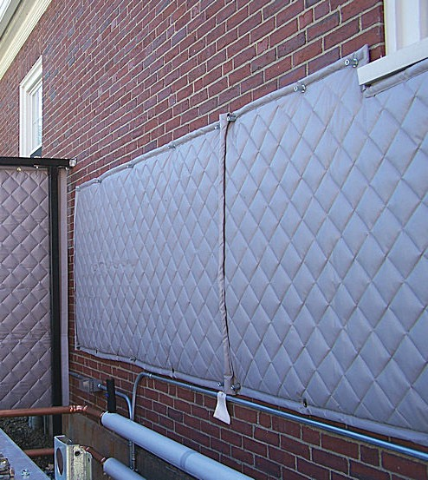



*Intelligent Acoustic Solutions*

**SPEC DATA SHEET # QFA-EXT-D2**

**APPLICATIONS:**

Typically used to reduce reverberant noise on construction sites where the product may be subjected to sunlight, rain, snow, and winds. It is commonly installed over wood fencing or on brick or masonry walls of buildings adjacent to a job site or a noisy piece of machinery.

**PRODUCT DATA DESCRIPTION:**

Vinyl Coated Polyester (VCP) facing/ 2” fiberglass batt Vinyl Coated Polyester (VCP) facing

**Nominal Thickness:** 2.0 inches

**Temperature Range:** -400 to +1800 F

**Standard Width:** 48” wide **Roll Length:** 25’ long **Weight:** 0.50 lb psf

**ACOUSTICAL PERFORMANCE:**

**Sound Absorption Performance:**

**OCTAVE BAND FREQUENCIES (HZ)**

ASTM C 423

4700 Clairton Blvd., Pittsburgh, PA 15236

Tel: (412) 884-3000 • Fax: (412) 884.3300

[www.oeler.com](http://www.oeler.com/)

•

[sales@oeler.com](mailto:sales@oeler.com)

*Intelligent Acoustic Solutions*

**Product 125 250 500 1K 2K 4K NRC**

**QFA-EXT-D-2”** 0.19 0.99 0.96 0.80 0.57 0.33 0.85