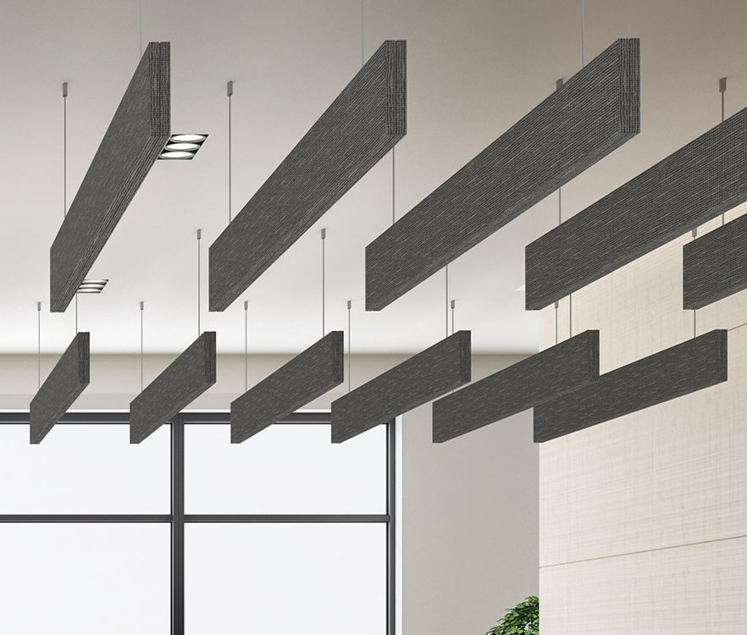

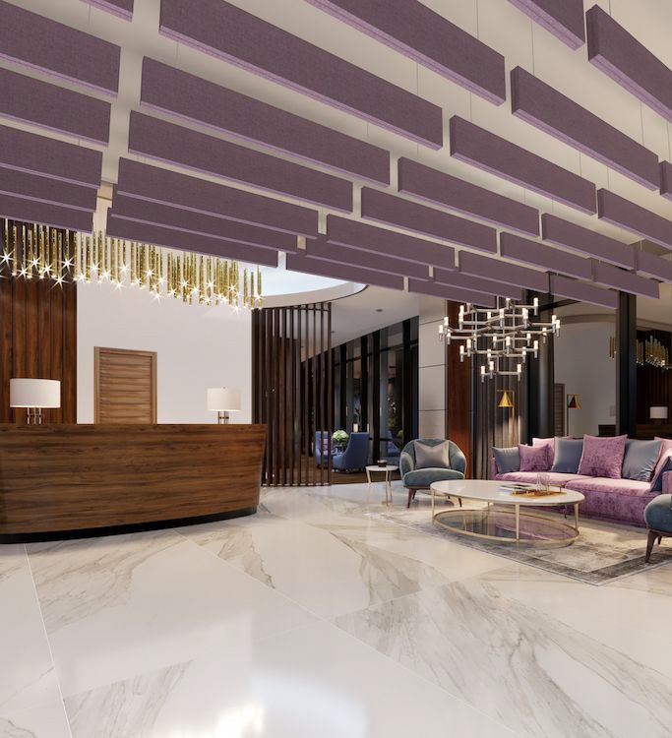

**SPEC DATA SHEET # R-100 Baffles**

4700 Clairton Blvd., Pittsburgh, PA 15236

Tel: (412) 884-3000

[www.oeler.com](http://www.oeler.com/)

•

•

Fax: (412) 884-3300

[sales@oeler.com](mailto:sales@oeler.com)

*Intelligent Acoustic Solutions*

**R-100**

**Baffles**

Oelex R-100 Baffles by Oeler Industries, Inc. are ideal for applications that require hanging baffles with “crisp” corners, a fabric finish, and high acoustical ratings.

R-100 Baffles are available in a 1” or 2” thickness.

Standard size is 2’x4’ with custom sizes up to a maximum of 4’x10’.

**APPLICATIONS:**

•

•

•

•

•

•

Libraries

Convention Centers Food halls

Offices Lobbies

Schools

**FEATURES:**

•

•

•

•

•

•

•

High-quality fabric finished baffle

Excellent acoustical performance Standard, designer or C.O.M. fabrics Custom sizes and shapes

New & improved hardware Easy to install

Class A fire rated





*Intelligent Acoustic Solutions*

**SPEC DATA SHEET # R-100 Baffles**

**SUBSTRATE:**

6-7 PCF rigid fiberglass core. Chemically hardened edges standard.

**FINISHES:**

•

Guilford of Maine FR 701 Style 2100 is

standard Sailcloth Nylon Webcore Vinyls

Designer and customer specified fabrics

are available

•

•

•

**MOUNTING:**

Grommets Eye hooks Brackets

**EDGE DETAIL:**

Square Bevel Radius Miter

**FIRE RATING:**

All components

shall have

a

Class

A

fire

rating per ASTM E-84.

**ACOUSTICAL PERFORMANCE:**

**1/3 Octave Sound Absorption Coefficients at the Octave Band Frequencies**

Tested ber ASTM C423-90a

4700 Clairton Blvd., Pittsburgh, PA 15236

Tel: (412) 884-3000 • Fax: (412) 884.3300

[www.oeler.com](http://www.oeler.com/)

•

[sales@oeler.com](mailto:sales@oeler.com)

*Intelligent Acoustic Solutions*

**Frequency (Hz) 125 250 500 1K 2K 4K SABINS**

**1” Thickness** 1.95 6.8 13.2 17.0 17.4 17.2 13.6

**2” Thickness** 2.85 7.25 13.7 18.1 18.0 16.9 14.3