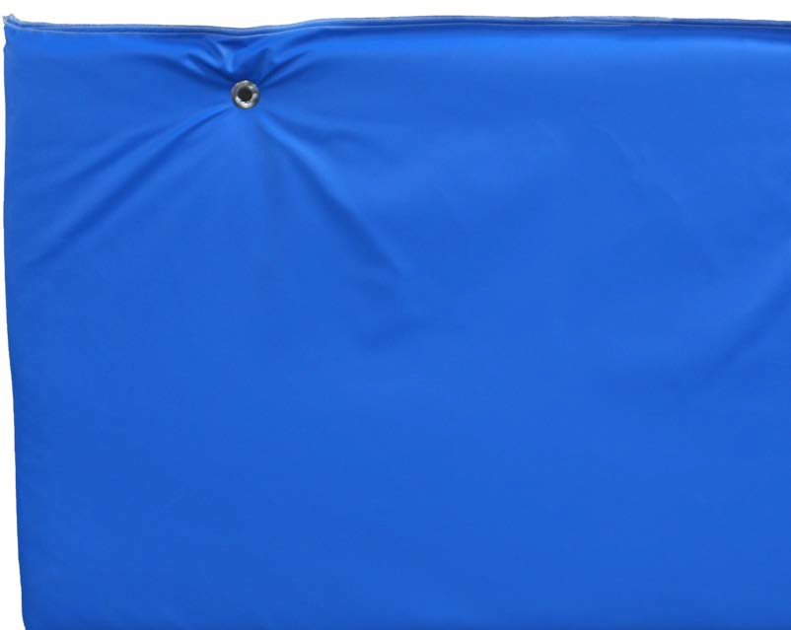

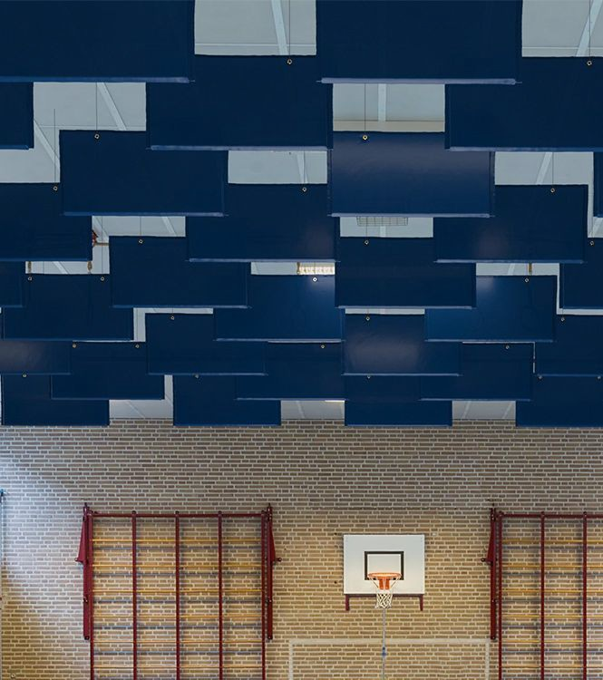

**SPEC DATA SHEET # SR-100**

4700 Clairton Blvd., Pittsburgh, PA 15236

Tel: (412) 884-3000

[www.oeler.com](http://www.oeler.com/)

•

•

Fax: (412) 884-3300

[sales@oeler.com](mailto:sales@oeler.com)

*Intelligent Acoustic Solutions*

**SR-100**

**BAFFLES**

Oelex SR-100 Semi-Rigid Baffles by Oeler

Industries, Inc. are the perfect

economical

solution to

reverberation issues

for

large

spaces. They are easy to install

suspended

down from the ceiling via

SR-100 Semi-Rigid Baffles made with a wide variety sizes available.

grommets. The

are all custom

of

finishes

and

**Applications:**

•

•

•

•

•

School gymnasiums

Swimming pools Multi-purpose rooms

Manufacturing environment

Field houses

**FEATURES:**

•

•

•

•

•

•

Low cost, economical baffles

Excellent acoustical performance Stitched edges for extra durability Custom sizing

Easy to install

Wide variety of finishes

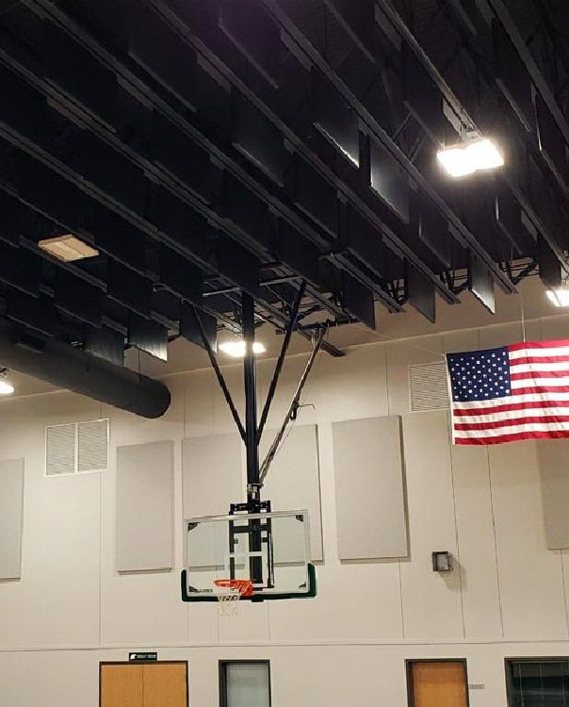



*Intelligent Acoustic Solutions*

**SPEC DATA SHEET # SR-100**

**SUBSTRATE:**

Standard: 2”, 1.5 PCF semi-rigid fiberglass core Also available: 1.5” thickness, 1.6 PCF

semi-rigid fiberglass core

**SIZING:**

SR-100 Baffles are available in custom sizes up to 4’ x 10’

**FINISHES:**

* Guilford of Maine FR 701 Style 2100 is standard

•

•

•

Sailcloth Nylon

PVC

Designer and customer specified fabrics are

available

**MOUNTING:**

Grommets

**EDGE DETAIL:**

Stitched

**FIRE RATING:**

All components per ASTM E-84.

shall have

a

Class A fire

rating

**ACOUSTICAL PERFORMANCE:**

**1/3 Octave Sound Absorption Coefficients at the Octave Band Frequencies**

Tested as Type “J” Mount

4700 Clairton Blvd., Pittsburgh, PA 15236

Tel: (412) 884-3000 • Fax: (412) 884.3300

[www.oeler.com](http://www.oeler.com/)

•

[sales@oeler.com](mailto:sales@oeler.com)

*Intelligent Acoustic Solutions*

**Frequency (Hz)** 125 250 500 1K 2K 4K SABINS

**2” Thick (PVC)** 1.94 4.68 11.61 11.84 6.04 2.66 8.54

**2” Thick (PVC) Wall Mount** 0.38 0.82 1.19 0.74 0.32 0.14 0.75

**1 1/2” Thick (Sailcloth)** 1.37 4.86 9.21 13.55 8.39 4.70 9.0

**1 1/2” Thick (Fabric)** 1.95 6.8 13.2 17.0 17.4 17.2 13.6