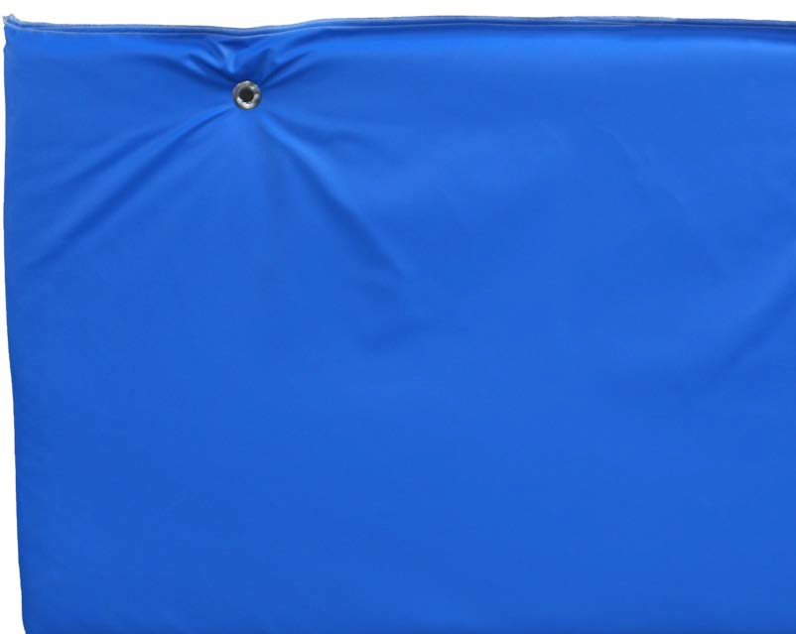

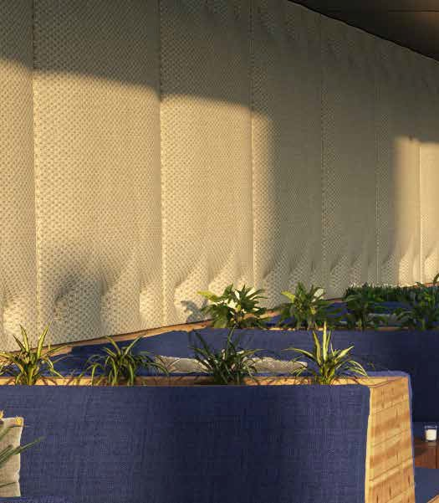

**SPEC DATA SHEET # SR-200**

4700 Clairton Blvd., Pittsburgh, PA 15236

Tel: (412) 884-3000

[www.oeler.com](http://www.oeler.com/)

•

•

Fax: (412) 884-3300

[sales@oeler.com](mailto:sales@oeler.com)

*Intelligent Acoustic Solutions*

**SR-200**

**SOUND ABSORPTION BAFFLES**

Oelex SR-200 Baffles by Oeler Industries,

Inc. are an

economic, efficient

solution

SR-200

chloride

to

sound

reverberation issues. The

baffle is comprised

of a

poly-vinyl

bag

encompassing

a

sound

absorptive

fiberglass, with a reinforced

edge binding sewn

around the entire perimeter of each baffle to

prevent hanging baffles or as longer banners;

either is available

black.

in white,

gray,

or

Grommets are installed for suspending

baffles or banners from wire or cable ties.

the

**FEATURES:**

•

•

•

•

NRC rating 11.0 per 4’x2’ baffle

Class A (or 1) per ASTM E84 The white facing is light reflective Lightweight, easy to install

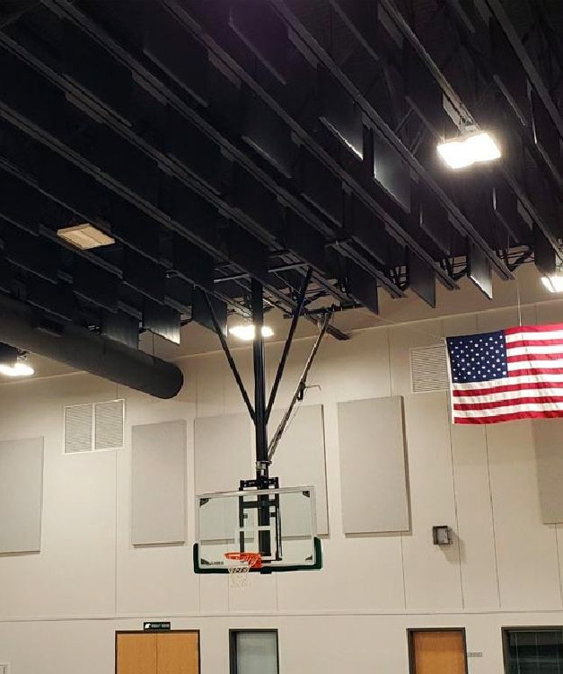



*Intelligent Acoustic Solutions*

**SPEC DATA SHEET # SR-200**

**APPLICATIONS:**

Typically used in areas where you want to introduce soft, sound absorption materials into hard, reflective environments to reduce the reverberant noise energy in a room. This creates an improved acoustical environment with lower noise levels and clearer communication in such applications as wood working facilities, manufacturing plants, gymnasiums, sports arenas, environmental control booths, and music rooms.

**PRODUCT DATA**

**Description:** 1.6lb/ft3 fiberglass core inside sewn PVC bag.

**Standard Thickness:** 1”, 11/2“, 2” **Standard Size:** Baffles: 48“ x 24”; Banners 48“ x any length to 25 feet

**Notes:** Additional sizes, fiberglass core

densities and thickness available.

a

**ACOUSTICAL PERFORMANCE:**

**(Sabin’s per 4’x2’ baffle)**

**OCTAVE BAND FREQUENCIES (HZ)**

Test method: ASTM C423-99a

4700 Clairton Blvd., Pittsburgh, PA 15236

Tel: (412) 884-3000 • Fax: (412) 884.3300

[www.oeler.com](http://www.oeler.com/)

•

[sales@oeler.com](mailto:sales@oeler.com)

*Intelligent Acoustic Solutions*

**Product 125 250 500 1K 2K 4K NRC**

**SR-200 baffle** 1.74 6.13 10.39 11.63 6.32 4.48 11.0