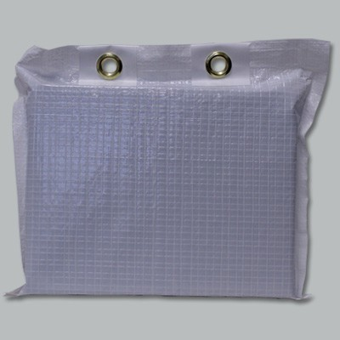

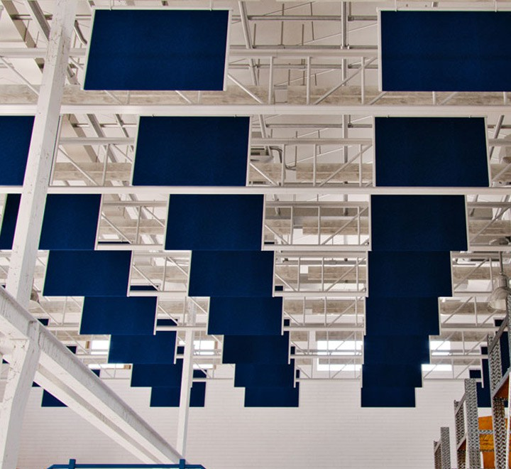

**SPEC DATA SHEET # SANITARY BAFFLES**

4700 Clairton Blvd., Pittsburgh, PA 15236

Tel: (412) 884-3000

[www.oeler.com](http://www.oeler.com/)

•

•

Fax: (412) 884-3300

[sales@oeler.com](mailto:sales@oeler.com)

*Intelligent Acoustic Solutions*

**BAFFLE SERIES**

**SANITARY BAFFLES**

Oelex Sanitary Baffles by Oeler Industries, Inc.

are an effective, economic method of

reducing

sanitary products

reverberant

noise

in

areas

where

conditions and USDA OR FDA approved

are mandatory. We use the latest in film technology

to create economic products that are durable, chemically resistant, and dimensionally stable.

Oelex Sanitary Baffles are tough enough to be

washed down and maintain high NRC sound

absorption

values. Two

baffle

styles

are

available, Type “A” for standard duty incorporates a

1 1/2” thick 1.6lb. density fiberglass core. Type “B” features additional internal reinforcement at each grommet to withstand daily high pressure, hot water wash down in addition to a higher density (3lb./cu.ft.) 2” thick fiberglass core for improved acoustical performance.

**FEATURES:**

•

•

•

•

•

•

•

•

•

•

FDA Approved, USDA listed

Washable

Temperature Range: -400F to 2000F Rip resistant facing

Dimensionally stable Stain Resistant

Meets health and sanitary standards Watertight seal on all edges

Light reflective white facing

Custom sizes available

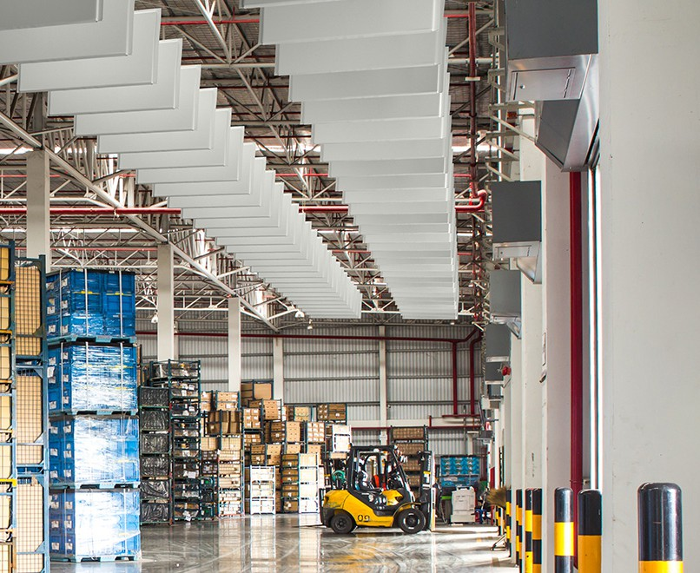

**Sound Absorption Coefficients-Sabin’s Per Baffle:**



*Intelligent Acoustic Solutions*

**SPEC DATA SHEET # SANITARY BAFFLES**

**APPLICATIONS:**

•

•

•

•

•

•

•

•

•

•

•

•

•

Food processing plants

Meat packaging plants Poultry processing plants Pharmaceutical facilities Clean rooms

Hospitals

Animal hospitals, kennels Bottling plants, canneries Breweries, wineries Cafeterias

Institutional kitchens Swimming pools

Plus O.E.M. applications

**ACOUSTICAL DATA:**

**Sanitary Baffle**

Type “A”: 2’ x 4’ x 1 1/2” thick

Type “B”: 2’ x 4’ x 2” thick

**ONE-THIRD OCTAVE BAND CENTER FREQUENCIES (HZ)**

Test method: ASTM C423-90a and C423-81

4700 Clairton Blvd., Pittsburgh, PA 15236

Tel: (412) 884-3000 • Fax: (412) 884.3300

[www.oeler.com](http://www.oeler.com/)

•

[sales@oeler.com](mailto:sales@oeler.com)

*Intelligent Acoustic Solutions*

**Sanitary Baffle 125 250 500 1K 2K 4K NRC**

**Type “A”** 1.15 5.26 8.0 10.9 9.34 5.5 8.4

**Type “B”** 1.00 8.09 14.65 15.72 12.68 4.93 12.8