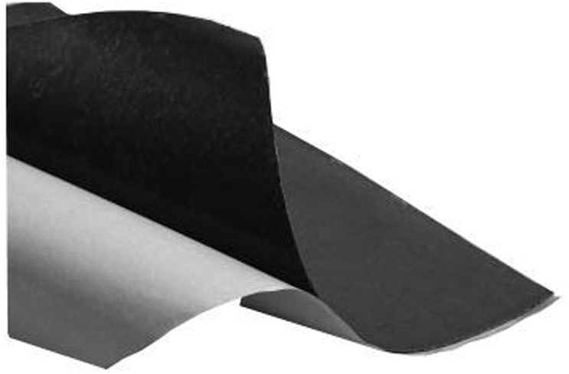

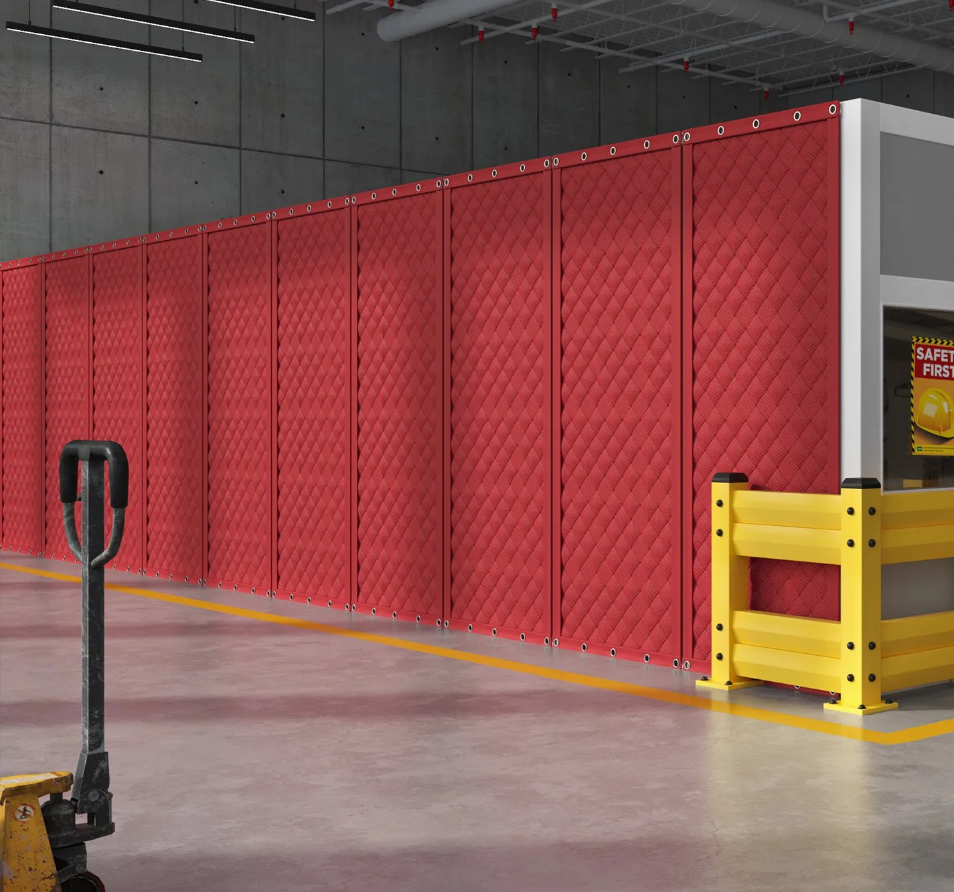

**SPEC DATA SHEET # VIBRATION DAMING SHEETS**

4700 Clairton Blvd., Pittsburgh, PA 15236

Tel: (412) 884-3000

[www.oeler.com](http://www.oeler.com/)

•

•

Fax: (412) 884-3300

[sales@oeler.com](mailto:sales@oeler.com)

*Intelligent Acoustic Solutions*

**SOUNDAMP**

**VIBRATION DAMING SHEETS**

Oelex

Soundamp

V

a used

by

Oeler

Industries, Inc. is

bitumen-based,

self-adhesive

sheet

for

sound

and

vibration damping on metal panels. The adhesive

side is smooth, giving complete contact with the

underlying

channels.

surface

without

air

pockets

or

Oelex Soundamp V

and impregnated to

is odorless,

prevent the

wear-resistant

absorption of adhesive can

water. Both pad material and

withstand

+1200C

temperatures

between

-300C

are

and

highly

(-220F

to

+2480F)

and

resistant to aging.

**FEATURES:**

•

•

•

Meets FMVSS 302 and UL94 HBF

Resistant to water and mineral oils Improves fatigue life and safety

factor of treated surfaces

* High acoustic loss factor
* Non-hazardous & non-toxic

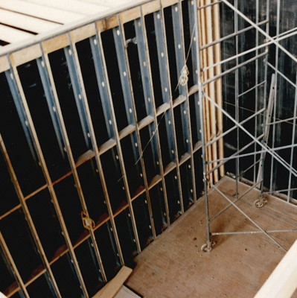



*Intelligent Acoustic Solutions*

**SPEC DATA SHEET # VIBRATION DAMING SHEETS**

**APPLICATIONS:**

Typically, applications include metal

partitions, ducts, transportation industry, and office machines as well as numerous architectural applications. Soundamp V is easily handled, and may be cut with scissors, utility knife, or die. Soundamp V should be cut into the desire shape before the backing paper is removed. The temperature of the pad and application surface should not be below room temperature during fitting.

**TYPICAL PROPERTIES:**

**Thickness:** 1.95MM (0.080”)

**Weight:** 1.6 kg/m2 (0.33 lbs/sq.ft.)

**Chemical Resistance:** Resistant to water and mineral oils **Thermal Conductivity:** (Y) -0.11 W/m K(0.76 BTU -in/ft2h x 0F **Storage Life:** 6 months max.

**Storage Instructions:** The material must be stored horizontally in its wrapping. **Fire Classification:** Meets FMVSS 302 and is approved to UL94 HBF **Temperature Range:** -220F to 2480F

**Thermal Conductivity:** 0.76 BTU/ in/ ft2/ Hr./ 0F

**ACOUSTICAL PERFORMANCE:**

**Sound Absorption Performance:**

**OCTAVE BAND FREQUENCIES (HZ)**

ASTM C 423

4700 Clairton Blvd., Pittsburgh, PA 15236

Tel: (412) 884-3000 • Fax: (412) 884.3300

[www.oeler.com](http://www.oeler.com/)

•

[sales@oeler.com](mailto:sales@oeler.com)

*Intelligent Acoustic Solutions*

**Product 125 250 500 1K 2K 4K NRC**

**QFA-EXT-D-2”** 0.19 0.99 0.96 0.80 0.57 0.33 0.85