Intelligent Acoustic Solutions

TONEWOOD-300
Built on the concept of creating high performance acoustical products with exceptional aesthetic value, Oelex ToneWood Topline by Oeler Industries, Inc. incorporate a variety of configurations to meet every acoustical requirement. Though flat, rigid materials are inherently reflective, balancing sound reflection and absorption is achieved through perforation. Perforated rigid materials, in conjunction with absorptive backings, allow for aesthetically pleasing finishes along with exceptional acoustic performance.

In wall applications where little space is afforded, it provides a means of preventing bleed- through of the color of the acoustic material installed behind the panels. In applications where there is a minimum of 8” of airspace behind the panels, this may be the only acoustic material necessary. A special kerfed tongue and groove edge detail is cut into the long edges which allows for an overall monolithic appearance. Typical plank size is 5” or 11 3/8” wide by 108” long. These standard sizes can be custom tailored to fit each application.
SPEC DATA SHEET # ToneWood-300
4700 Clairton Blvd., Pittsburgh, PA 15236
Tel: (412) 884-3000 • Fax: (412) 884-3300
www.oeler.com • sales@oeler.com

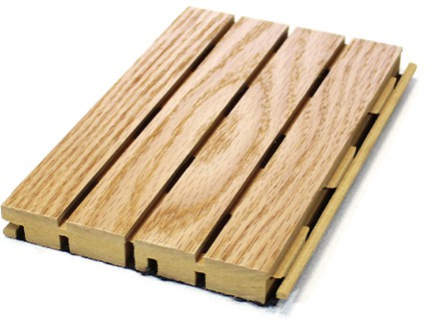
FEATURES:
- Class A fire rated, CARB2
- Typical plank size is 5" x 96" long
- Tongue & groove edge detail
- Monolithic appearance
- Custom sizes available

4700 Clairton Blvd., Pittsburgh, PA 15236
Tel: (412) 884-3000 • Fax: (412) 884.3300
www.oeler.com • sales@oeler.com
Intelligent Acoustic Solutions

Intelligent Acoustic Solutions
SPEC DATA SHEET # ToneWood-300
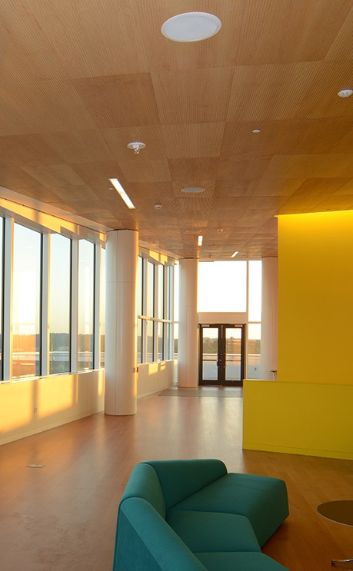
ACOUSTIC PERFORMANCE
Noise Reduction Coefficient (NRC)*
Topline SoundTex 1”-3 PCF
Model # Only Fiberglass
2”-3 PCF 1”-6 PCF 2”-6 PCF 1”-3 PCF 2”-3 PCF
Fiberglass Fiberglass Fiberglass Fiberglass Fiberglass
w/ 50mm w/ 200mm airspace airspace

6/2 | .70 | .80 | .90 | .85 | .95 | .90 | .95
5/3 | .75 | .85 | .95 | .80 | .85 | .90 | .95
14/2 | .55 | .75 | .75 | .70 | .75 | .80 | .80
13/3 | .55 | .70 | .75 | .70 | .75 | .75 | .85
28/4 | .50 | .65 | .65 | .65 | .65 | .65 | .65
29/3 | .45 | .55 | .60 | .60 | .65 | .65 | .70

* Octave band data available upon request

INSTALLATION DETAILS
Installation of ToneWood Topline Acoustical Wood planks is made simple by virtue of a special tongue and groove arrangement designed to work in conjunction with our 5/0 nail clip. This nail clip engages the tongue and groove while still allowing for an overall monolithic appearance.

Except in special circumstances, no adhesives or nailing into the product is necessary. A simple arrangement of furring is used to provide room for acoustical materials behind the planks and provide a level, secure surface to which to attach nail clips. Field cutting of the Topline planks is no different than cutting any wood product. Typical woodworking tools are used.

Special consideration should be made for preserving the face side of the product. While small dents and scratches can be repaired, major abrasions to the face of the plank should, of course, be avoided.

CARE & MAINTENANCE
As with most interior finish products, materials should be stored in areas with functional HVAC systems. Before installation, panels should be allowed to acclimatize to the environment in which they will be installed, for 72 hours. Ideal environmental conditions are 72°F, with a relative humidity of between 45% and 55%.

After installation, the panels should be treated as any fine piece of furniture would be treated. A final cleaning with a soft cloth and any good furniture polish will enhance and preserve the luster of the finish. Periodic maintenance of a similar nature will preserve the look and the performance of ToneWood Topline for many years to come.

