Intelligent Acoustic Solutions

TONEWOOD-600
With its parallel straight lines, Oelex ToneWood Linear for Walls and Ceilings by Oeler Industries, Inc. creates a clean and continuous aesthetic look while achieving NRC values as high as .90. The system is built on a 17 mm (11/16”) thick MDF core finished with two coats of a UV-polyacrylate lacquer.

ToneWood Linear is a traditional wall and ceiling product that combines the warmth of wood with excellent acoustical values. The plank edges receive the same real wood edge banding. Choose either planks or panels for your application needs.

LEED & SUSTAINABILITY:
- FSC Certified and Chain-of-Custody manufacturer
- Opportunity for Credits: MR 4.1, MR 4.2, MR 7, EQ 4.4

FEATURES:

SPEC DATA SHEET # ToneWood-600
4700 Clairton Blvd., Pittsburgh, PA 15236
Tel: (412) 884-3000 • Fax: (412) 884-3300
www.oeler.com • sales@oeler.com

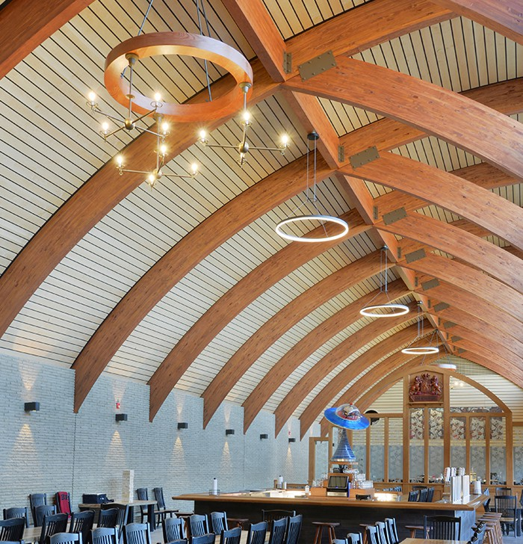
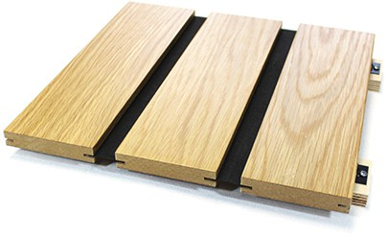
  - Plank widths available from 2 -1/2” up to 12”
  - Plank lengths available up to 120”
  - Reveal widths available from hairline up to 1- 3/16”
  - Reveal edge or flush edge detail
  - Acoustical textile at reveal provides acoustical performance

Planks can be perforated higher NRC ratings.
for even

Intelligent Acoustic Solutions
SPEC DATA SHEET # ToneWood-600

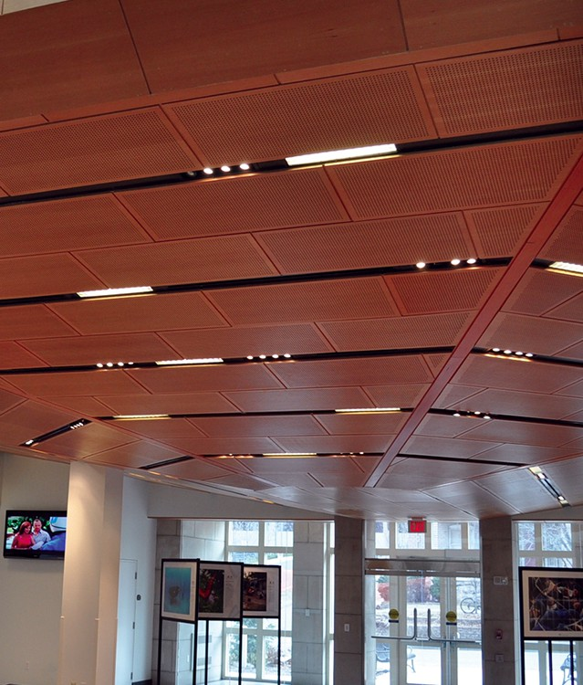

OPTIONS:

SOUND ABSORPTION DATA:
Frequencies (Hz)

Perforation  % of Openings | 125 | 250 | 500 | 1000 | 2000 | 4000 | NRC
7.2% Open | 0.29 | 0.58 | 0.55 | 0.51 | 0.48 | 0.53 | 0.55
18% Open | 0.13 | 0.34 | 1.15 | 1.08 | 0.55 | 0.53 | 0.80

*Acoustics is determined based upon % of opening in face of wood. Consult factory for availability.

FINISHES
24 standard veneers are readily available, or any type of specialty / engineered veneer offered in the global marketplace can be obtained to allow an architect or interior designer limitless choices.
- Beech
- Oak
- Cherry
- Ash
- Walnut

  - All widths available from 2-1/2” to 12” and greater
4700 Clairton Blvd., Pittsburgh, PA 15236
Tel: (412) 884-3000 • Fax: (412) 884-3300
www.oeler.com • sales@oeler.com
Intelligent Acoustic Solutions
  - All lengths available up to 9’-1 ½”
  - A full 3/4” thickness is available
  - Reveal width may vary from a hairline to 30 mm (1- 3/16”)
  - Acoustical textile at reveal provides “open area” for acoustical performance
  - Perforations in planks increase the “open area” for a higher NRC acoustical value
  - Acoustical insulation board can be added behind the plank for greater sound absorption
  - Class A fire rated, Class C non-fire rated, No Added Urea Formaldehyde, CARB2
  - Plastic laminate, painted or matte lacquer finishes available
  - Exterior installations allowed at suitable weather protected areas (underside of canopies or similar)

TONEWOOD LINEAR REVEAL CLIP SIZES (WIDTH):
  - 0 mm (Hairline)
  - 5 mm (3/16”)
  - 10 mm (3/8”)
  - 15 mm (9/16”)
  - 20 mm (3/4”)
  - 30 mm (1-3/16”)
  - Custom options available

