Intelligent Acoustic Solutions

TONE WOOD-100
Oelex ToneWood 100 by Oeler Industries, Inc. is a traditional wall panel product that combines the warmth of wood with excellent acoustical values; either acoustically reflective or absorptive when perforated.

The product consists of a MDF core material with a face veneer and a rear balancing veneer. The applied finish is two coats of UV-polyacrylate clear lacquer.

The ToneWood for Walls is offered in three edge details. The Reveal Edge detail can use different size screw clips that provide widths between panels that vary from a hairline up to 30 mm. A Square Edge allows for the full thickness of the panels to be visible which are edge banded, these panels are typically installed using concealed Z-clips.

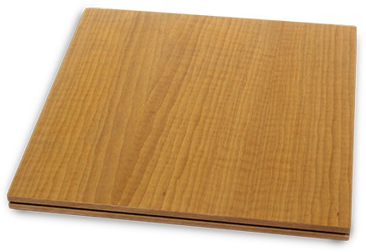
FEATURES:
SPEC DATA SHEET # ToneWood-100
4700 Clairton Blvd., Pittsburgh, PA 15236
Tel: (412) 884-3000 • Fax: (412) 884-3300
www.oeler.com • sales@oeler.com

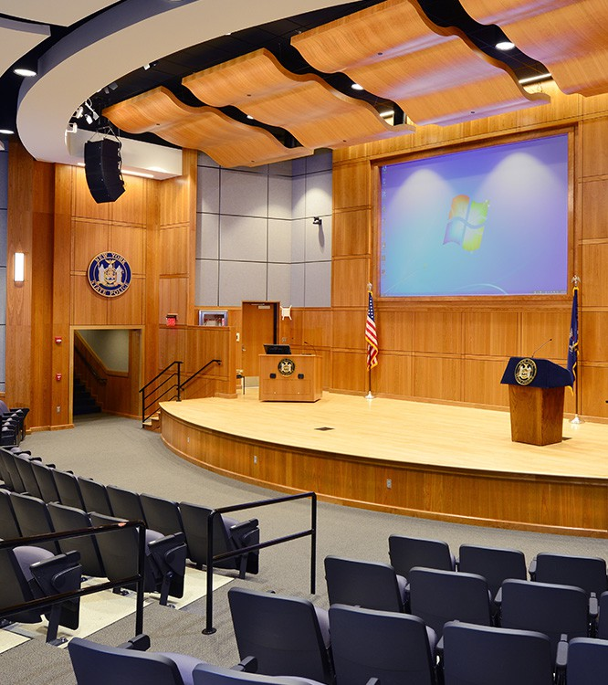
- Class A fire rated, CARB2
- Concealed mounting hardware
- Multiple finish options available
- Panel widths up to 4'
- Panel lengths up to
10'

Intelligent Acoustic Solutions
SPEC DATA SHEET # ToneWood-300

SOUND ABSORPTION DATA:
Frequencies (Hz)

Perforation  % of Openings | 125 | 250 | 500 | 1000 | 2000 | 4000 | NRC
7.5% Open | 0.29 | 0.58 | 0.55 | 0.51 | 0.48 | 0.53 | 0.55
18% Open | 0.13 | 0.34 | 1.15 | 1.08 | 0.55 | 0.53 | 0.80
24% Open | 0.27 | 0.81 | 0.78 | 0.95 | 0.96 | 0.93 | 0.90
*Acoustics is determined based upon % of opening in face of wood. Consult factory for availability.
TYPICAL VENEER SELECTION:
Standard for Walls, being produced with a .6mm “A” quality veneer is available in a multitude of veneer selections. With over 60 wood species available, an architect or interior designer has almost limitless choices.

4700 Clairton Blvd., Pittsburgh, PA 15236
Tel: (412) 884-3000 • Fax: (412) 884.3300
www.oeler.com • sales@oeler.com
Intelligent Acoustic Solutions
Green Blade Havana | Oak | Cherry
Ash | Walnut | Beech

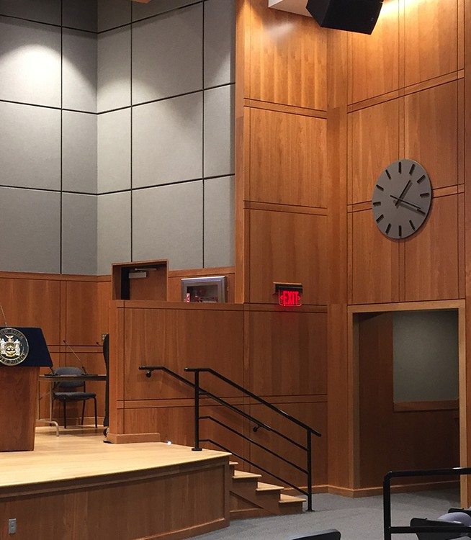
*Other veneers available upon request.

INSTALLATION DETAILS

ToneWood panels shall be installed by means of a screw clip or Z clip on furring attached to wall substrate, with maximum nail clip spacing of 24” OC. It is recommended to fill the cavity behind the ToneWood product with fiberglass for better acoustical results.

CARE & MAINTENANCE

As with most interior finish products, materials should be stored in areas with functional HVAC systems. Before installation, panels should be allowed to acclimatize to the environment in which they will be installed, for 72 hours.

LEED & SUSTAINABILITY

- FSC Certified and Chain-of-Custody manufacturer
- Opportunity for Credits: MR 4.1, MR 4.2, MR 7, EQ 4.4

