Intelligent Acoustic Solutions

TONEWOOD 200
You only get one chance to make a first impression. With Oelex ToneWood 200 by Oeler Industries, Inc., it’s always a good one.

These acoustical panels are comprised of a wood veneered MDF board facing and a backing made from 100% Polyethylene Terephthalate (PET) a 100% recyclable material.

COMPOSITION
Facing:
•Wood-veneered MDF board
- Backing:
- 100% Polyethylene Terephthalate (PET)
- 55% recycled content

ENVIRONMENTAL FACTORS
- PET is 100% recyclable
- Low VOC emissions
- ASTM — D51116
- LEED — MRc4

FEATURES:

SPEC DATA SHEET # ToneWood-200
4700 Clairton Blvd., Pittsburgh, PA 15236
Tel: (412) 884-3000 • Fax: (412) 884-3300
www.oeler.com • sales@oeler.com

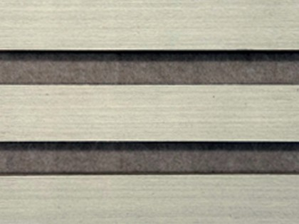
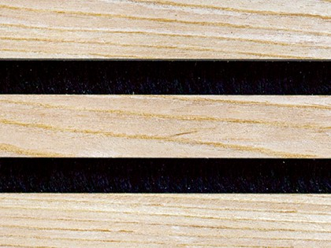
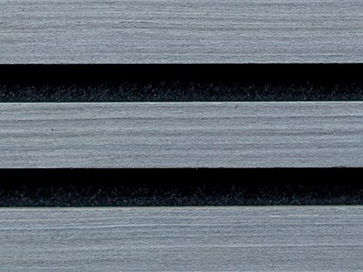
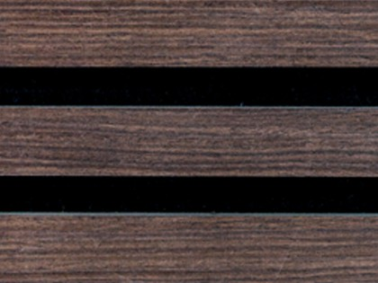
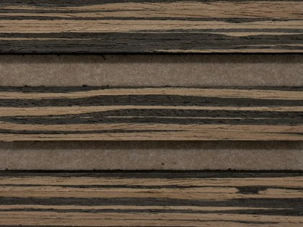
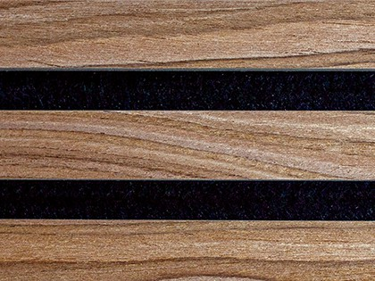
  - Quick & easy installation
  - Application on walls or ceilings
  - Cut to size in the field
  - Built-in spacers
  - Easy to handle
  - Linear design
  - Choice of 6 woodgrain veneers

4700 Clairton Blvd., Pittsburgh, PA 15236
Tel: (412) 884-3000 • Fax: (412) 884.3300
www.oeler.com • sales@oeler.com
Intelligent Acoustic Solutions

Intelligent Acoustic Solutions

SPEC DATA SHEET #TONEWOOD-200
ACOUSTICAL DATA:

1/3 Octave Sound Absorption Coefficients at the Octave Band Frequencies

Frequency (Hz) | 125 | 250 | 500 | 1000 | 2000 | 4000 | NRC
 | 0.08 | 0.08 | 0.29 | 0.70 | 1.07 | 0.83 | 0.55
Type “A” mount – flat
Frequency (Hz) | 125 | 250 | 500 | 1000 | 2000 | 4000 | NRC
 | 0.04 | 0.18 | 0.50 | 1.02 | 1.04 | 0.77 | 0.70
Modified Type D-20 mount – 1” airspace
Frequency (Hz) | 125 | 250 | 500 | 1000 | 2000 | 4000 | NRC
 | 0.17 | 0.39 | 0.87 | 1.10 | 0.81 | 0.84 | 0.80
Modified Type D-50 mount – 2” airspace

SPECIFICATIONS:

- Panel Size: 24” x 96”
- Thickness: 0.87”
- Weight: 35 lbs / panel
- Fire Rating: Class B per ASTM E-84-21a

INSTALL METHODS:

- Wall: Furring strip, direct with screws & adhesive
- Ceiling: Furring strip

