Intelligent Acoustic Solutions

TONEWOOD 400
The Oelex ToneWood Basic by Oeler Industries, Inc. features a genuine wood veneered lay-in tegular edge panel designed for installation in a 15/16" or 9/16" T-grid. ToneWood Basic is produced with a natural finish by applying two coats of a clear UV-polyacrylate lacquer.

Custom staining is available, as well as the 24 standard and 40 custom veneers that are offered. State-of-the-art CNC machinery produces specified perforations or slots to achieve optimum acoustical results. Where design dictates non-perforated, reflective panels are also available.
SPEC DATA SHEET # TONEWOOD-400
4700 Clairton Blvd., Pittsburgh, PA 15236
Tel: (412) 884-3000 • Fax: (412) 884-3300
www.oeler.com • sales@oeler.com

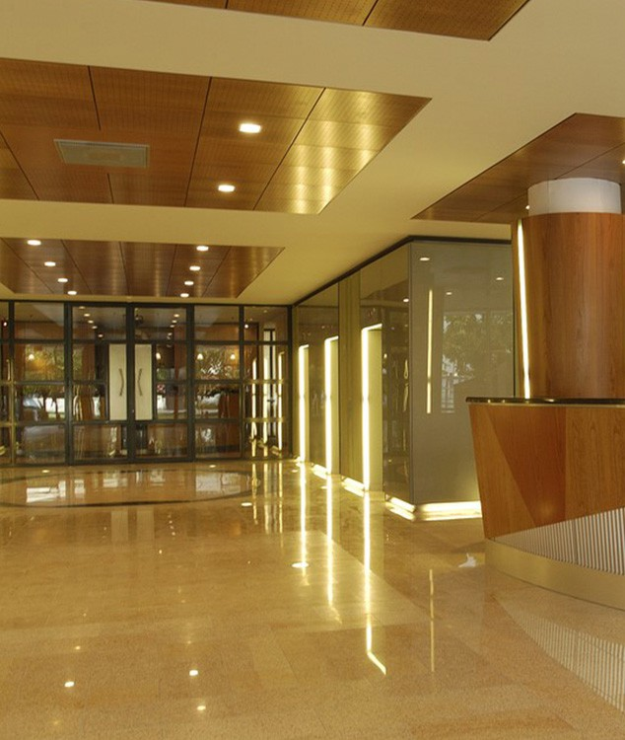

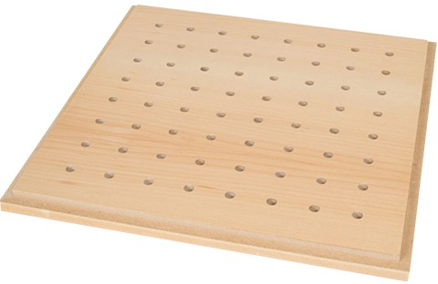
FEATURES:
- Class A fire rated, CARB2
- MDF Core
- Standard sizes of 2'x2' | 2'x4' | 1'x6'
- Custom sizes available
- Custom edge detail available for compatibility with non-standard grids.

4700 Clairton Blvd., Pittsburgh, PA 15236
Tel: (412) 884-3000 • Fax: (412) 884.3300
www.oeler.com • sales@oeler.com
Intelligent Acoustic Solutions

Intelligent Acoustic Solutions
SPEC DATA SHEET # TONEWOOD-400
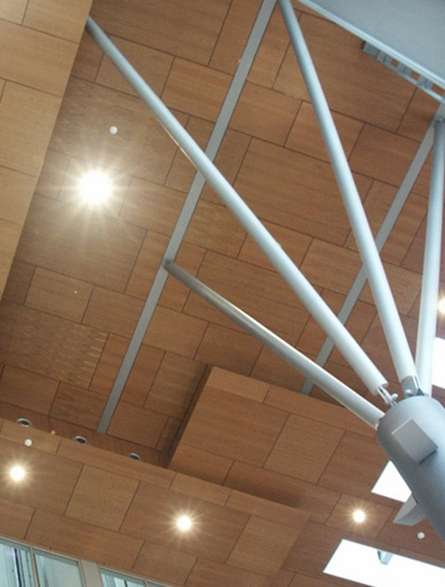
SOUND ABSORPTION DATA:
Frequencies (Hz)
Perforation
% of Openings
125 250 500 1000 2000 4000 NRC

7.2% Open | 0.29 | 0.58 | 0.55 | 0.51 | 0.48 | 0.53 | 0.55
18% Open | 0.13 | 0.34 | 1.15 | 1.08 | 0.55 | 0.53 | 0.80
24% Open | 0.27 | 0.81 | 0.78 | 0.95 | 0.96 | 0.93 | 0.90
*Acoustics is determined based upon % of opening in face of wood. Consult factory for availability.
TYPICAL VENEER SELECTION:

Afzelia | Black Walnut | Khaya Mahogany
African Oak | Carolina Pine | Maple
American Oak | Cedar | Oregon Pine
Anigre | Cherry | Padouk
Ash | Conga Walnut | Pear
Beech Steamed | Elm | Rosewood
Beech Unsteamed | European Oak | Sapeli Mahogany
Birds-Eye Maple | Koto | Teak
*Other veneers available upon request.
CUSTOM SPECIFICATIONS: SECTION 09570 - WOOD WALL PANELS
PART 1 - GENERAL
  - Scope - The work consists of furnishing all material, labor, and accessories necessary to install ToneWood Basic Acoustical Wood Systems specified herein.
  - Delivery and Storage - All material shall be delivered in their original unopened cartons and stored in an enclosed area providing protection from damage and exposure to the elements. Prior to installation, panels shall be acclimated for 72 hours at the temperature and humidity conditions during installation and occupancy. PART 2 - MATERIAL
2.1 Material 2.2 ToneWood Basic Acoustical Wood Systems as manufactured by Sound Seal, P.O. Box 545, Agawam, MA 01001. Phone: 1-800-569-1294 Fax: 413-789-4444 2.3 Panels shall be ToneWood Basic for Walls/Ceilings and be 17mm thick MDF with blind veneer backer, sized as noted. 2.4 ToneWood Basic panels shall be available in first quality select veneer from over 64 species. Available with special staining and lacquring to match architects samples. 2.5 ToneWood Basic panels shall be constructed using fire rated components meeting or exceeding the requirements of the ATSM E-84 Class (A,B,C) Flame Spread: (A) 25 or less, (B) 26 - 27, (C) 76 to 200 Smoke Developed: 450 or less. 2.6 ToneWood Custom panels shall have a minimum NRC rating of with perforation pattern # , and an open area of %. 2.7 ToneWood Basic panels can be installed by means of several different systems to suit your needs. PART 3 - EXECUTION
3.1 Installation 3.2 ToneWood Basic panels shall be installed a shown or interior elevation drawings and indicated on room finish schedule. 3.3
ToneWood Basic panel installation shall not begin until all wet work is completed and panels have been allowed to acclimate for 72 hours. The installation contractor shall have at least 5 years of successful experience in this class of work. All ToneWood Basic panels shall be properly installed and free from dirt, dust, grease, oils, and fingerprints by wiping clean the surface with furniture polish.

