Intelligent Acoustic Solutions

TONEWOOD 410
The Oelex ToneWood Select by Oeler Industries, Inc. features a genuine wood veneered concealed grid ceiling panel system. Installed on typical z-bar, ToneWood Select provides for a continuous ceiling with panels defined by a small 2mm bevel on all edges. This system can be designed to complement casework, doors, and even furniture.

Custom staining is available, as well as the 24 standard and 40 custom veneers that are offered. State of the art CNC machinery produces the selection of perforation, slot, or groove patterns that achieve NRC values as high as .90. Where design dictates non-perforated, reflective panels are also available.
SPEC DATA SHEET # TONEWOOD-410
4700 Clairton Blvd., Pittsburgh, PA 15236
Tel: (412) 884-3000 • Fax: (412) 884-3300
www.oeler.com • sales@oeler.com

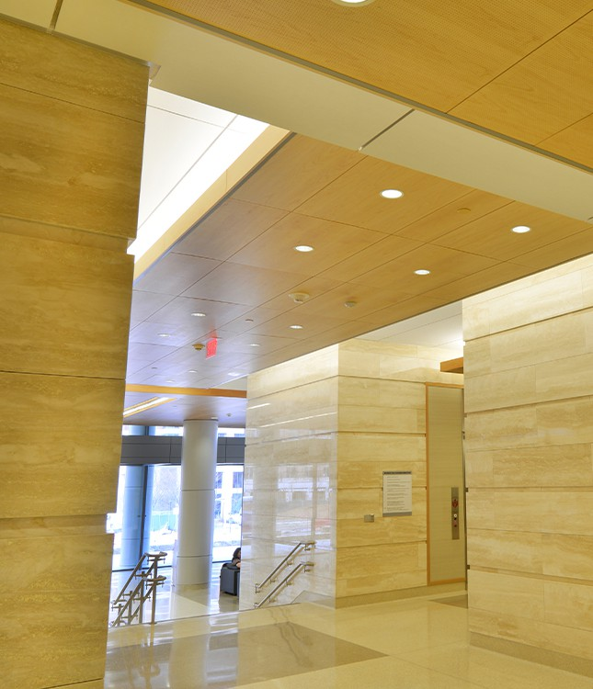

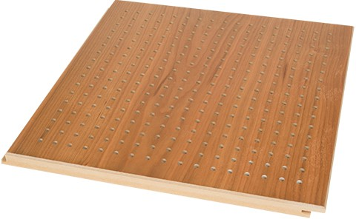
FEATURES:
- Class A fire-rated composites available
- NRC values as high as .90
- MDF, Chipboard, or plywood substrates
- Standard sizes 2’ x 2’, 2’ x 4’, 1’ x 6’
- Custom sizes available

4700 Clairton Blvd., Pittsburgh, PA 15236
Tel: (412) 884-3000 • Fax: (412) 884-3300
www.oeler.com • sales@oeler.com
Intelligent Acoustic Solutions

Intelligent Acoustic Solutions
SPEC DATA SHEET # TONEWOOD-400
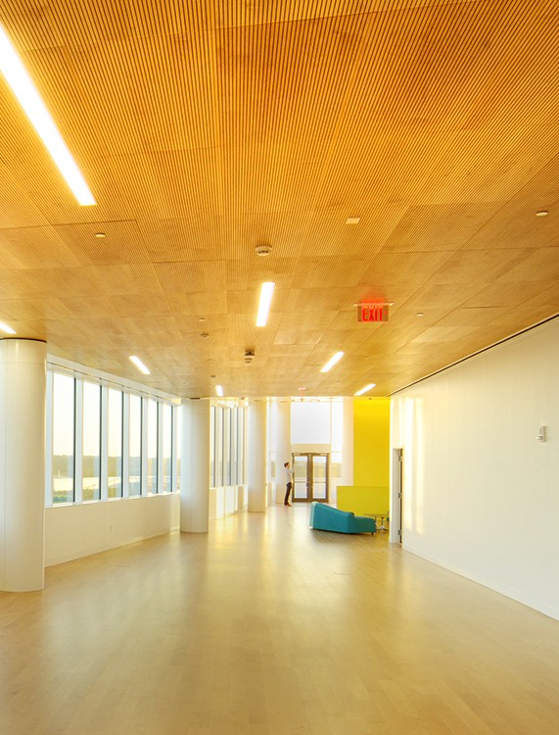
SOUND ABSORPTION DATA:
Frequencies (Hz)
Perforation
% of Openings
125 250 500 1000 2000 4000 NRC

7.2% Open | 0.29 | 0.58 | 0.55 | 0.51 | 0.48 | 0.53 | 0.55
18% Open | 0.13 | 0.34 | 1.15 | 1.08 | 0.55 | 0.53 | 0.80
24% Open | 0.27 | 0.81 | 0.78 | 0.95 | 0.96 | 0.93 | 0.90
*Acoustics is determined based upon % of opening in face of wood. Consult factory for availability.
TYPICAL VENEER SELECTION:

Afzelia | Black Walnut | Khaya Mahogany
African Oak | Carolina Pine | Maple
American Oak | Cedar | Oregon Pine
Anigre | Cherry | Padouk
Ash | Conga Walnut | Pear
Beech Steamed | Elm | Rosewood
Beech Unsteamed | European Oak | Sapeli Mahogany
Birds-Eye Maple | Koto | Teak
*Other veneers available upon request.
CUSTOM SPECIFICATIONS: SECTION 09570 - WOOD WALL PANELS
PART 1 - GENERAL
  - Scope - The work consists of furnishing all material, labor and accessories necessary to install ToneWood Acoustical Wood Systems specified herein.
  - Delivery and Storage - All material shall be delivered in their original unopened cartons and stored in an enclosed area providing protection from damage and exposure to the elements. Prior to installation, panels shall be acclimated for 72 hours at the temperature and humidity conditions during installation and occupancy. PART 2 - MATERIAL
  - Material 2.2 ToneWood Acoustical Wood Systems as manufactured by Oeler Industries, Inc., 4700 Clairton Blvd., Pittsburgh, PA 15236, Phone:
412-884-3000 Fax: 412-884-3300 2.3 Panels shall be ToneWood Select and be 2’ x 2’, 2’ x 4’, 1’ x 6’ or custom. 2.4 ToneWood Select Panels shall be available in first quality select veneer from standard selection of 24 wood species plus 40 additional species available with special staining and lacquering to match architects samples. 2.5 ToneWood Select panels shall be constructed using fire rated components meeting or exceeding the requirements of the ASTM E-84 Class (A,B,C) Flame Spead: (A) 25 or less, (B) 26 to 75, (C)76-200 Smoke Developed: 450 or less. 2.6 ToneWood Select panels shall have an NRC rating of with perforation pattern # and an open area of %. 2.7 ToneWood Select panels shall be installed by means of “drop-in” mounting on intermediate duty Z bar.
PART 3 - EXECUTION
3.1 Installation 3.2 ToneWood Select Panels shall be installed as shown on reflected ceiling plans and indicated on room finish schedule. 3.3 Panel installation shall not begin until all wet work is completed and panels have allowed to acclimate for 72 hours. The installation contractor shall have at least five years of experience in this class of work. All panels shall be properly installed and free from dirt, dust, grease, oils and fingerprints by wiping clean the surface with furniture polish.

