Intelligent Acoustic Solutions

TONEWOOD 500
The Oelex ToneWood Slat Wall by Oeler Industries, Inc. is a traditional linear wall and ceiling product that combines
the warmth of wood with excellent acoustical values. We utilize a Class A fire rated no added formaldehyde MDF core covered with your choice of veneer to maximize your finish offerings and to offer straighter lines than solid wood options.

SIZES & FINISHES
Oelex ToneWood Slat Wall ships in 1’ wide by 8’ long panels with arrangements featuring two to eight blades per panel. The standard finish is a natural clear lacquer. For a more personalized look, choose from 24 standard and 40 custom veneers available, sure to fit any design.

LEED INFO:
- Credits for MR 4.1, MR 4.2, MR 7, EQ 4.4
- No added Formaldehyde
- FSC certified and offers a chain-of-custody proof of origin

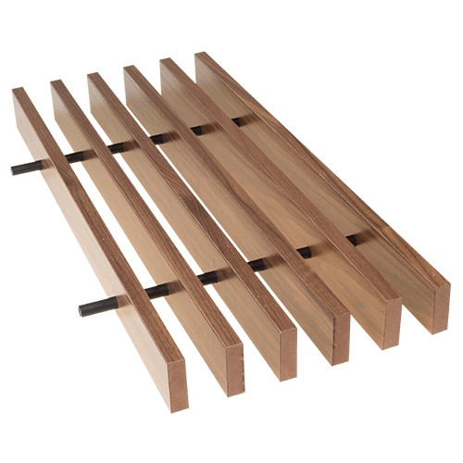
FEATURES:

SPEC DATA SHEET # ToneWood-500
4700 Clairton Blvd., Pittsburgh, PA 15236
Tel: (412) 884-3000 • Fax: (412) 884-3300
www.oeler.com • sales@oeler.com

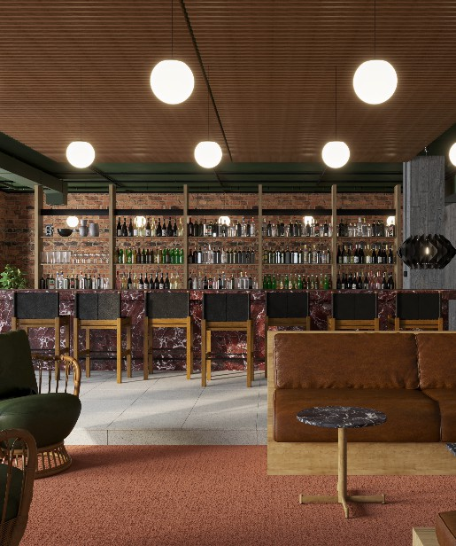
  - Class A fire rated, CARB2
  - Dowel or backer type assembly based on application
  - Typical blade widths of 5/8", 3/4", 1" or 1-1/4"
  - Typical blade heights of 1-3/4", 2-1/8", 2-1/2" or 3-1/8"
  - Custom sizes available

Intelligent Acoustic Solutions

SPEC DATA SHEET #TONEWOOD-500
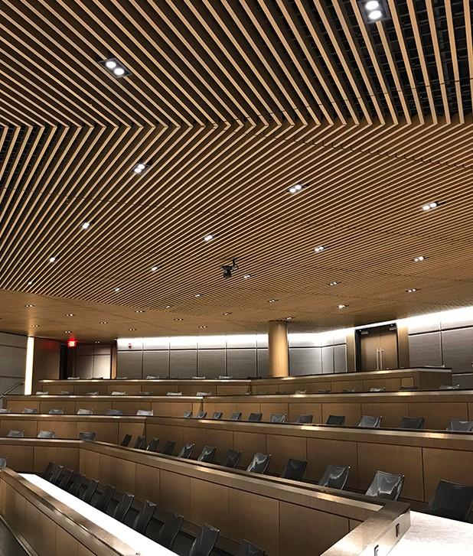
ACOUSTICS:
As with all Oelex products, acoustical performance is at the fore- front during the design phase of the products. Different acoustical mate- rials can be used both above and behind the grilles to garner acoustical results:

INSTALLATION:
- Oelex acoustic textile can easily and affordably be added to the back of the grilles
- Oelex black theater board can be incorporated into the design to enhance the acoustical performance

OPTIONS:
- Typical Grille sections are 12” wide by 8’ long
- Arrangements of 4, 6 or 8 blades per 12” section are standard
- Blades are typically 1 ½’, 2”, 2 ½” or 3” thick

FINISHES:
- 24 Standard & 40 custom veneers available
- Clear satin lacquer is the standard finish

4700 Clairton Blvd., Pittsburgh, PA 15236
Tel: (412) 884-3000 • Fax: (412) 884-3300
www.oeler.com • sales@oeler.com
Intelligent Acoustic Solutions
Convertible for walls or ceiling arrangements, our proprietary attachment clip provides a solid mounting option along with the ability to access equipment above or behind the grilles. Standard installation will have our attachment clip suspended from a heavy duty 15/16” T-Grid. Installation is simple and the attachment clips works with both the backer and dowel designs.

  - Recessed Wood backer: The black hardwood recessed backer holds the blades securely while disappearing into the background above.
  - Dowel Design: The dowels are often used in open plenum designs where the dowel itself becomes a design element. There are two dowel options. A hardwood (fixed) or a PVC (flexible) option.

WARRANTY:

All WoodTrends products come standard with a full one-year warranty for manufacturing defects and dimensional stability.

